Client: | CTICM/ARCELORMITTAL
Order reference: | Order N° 45584318 on 23/12/22  and contract AM/CTICM on 12/01/23
Project Index:  Product Index: | DRV/DAL-22-003/001-B  DRV/PMX/ST/001-B
ABC-PMX-II Software
Composite beam design

validation manual
Membre du Comité de Coordination des Centres de Recherche en mécanique / Siret : 775 728 785 00046 Code Naf : 7219 Z

Revision | Date | Authors | Subject
A | 26/01/2024 | G. DELACOURT | ABC-PMX-II Software – Validation Manual
B
C
D

Content
1. Introduction 2
2. References 2
2.1. First generation of Eurocodes 2
2.2. Drafts for the second generation of Eurocodes 2
2.3. Scientific references 2
3. Principles of validation 3
4. Tests cases 4
4.1. Test case 1: Simply supported composite beam (RCM 2018-2) 4
4.1.1. Input data 4
4.1.2. Results 11
4.2. Test case 2: Simply supported composite beam with partial encasement during its construction phase (RCM 2023-3) 14
4.2.1. Input data 14
4.2.2. Results 20

Introduction
ABC-PMX software aims at the calculation of composite beams according to EN 1994-1-1. Its development is co-funded by ArcelorMittal and CTICM. This documents constitutes the Validation Manual.

References

First generation of Eurocodes
- EN 1990 – Basic of structural design. AFNOR. March 2003.
- EN 1991-1-2: Eurocode 1: Actions on structures Part 1-2: General actions — Actions on structures exposed to fire
- EN 1992-1-1 – Design of concrete structures. Part 1-1: General rules and rules for buildings. AFNOR. October 2005.
- EN 1993-1-1 – Design of steel structures. Part 1-1: General rules and rules for buildings. AFNOR. October 2005.
- EN 1993-1-2 – Design of steel structures. Part 1-2: General rules - Structural fire design
- EN 1993-1-5 – Design of steel structures. Part 1-5: Plated structural elements. AFNOR. March 2007.
- EN 1994-1-1 – Design of composite steel and concrete structures. Part 1-1: General rules and rules for buildings. AFNOR. June 2005.
- EN 1994-1-2 – Design of composite steel and concrete structures. Part 1-2: General rules - Structural fire design

Drafts for the second generation of Eurocodes
- prEN 1992-1-1 – Design of concrete structures. Part 1-1: General rules and rules for buildings. Document SC2N2034
- FprEN 1993-1-1 – Design of steel structures. Part 1-1: General rules and rules for buildings. Document SC3 N3504 – 26/11/21
- FprEN 1993-1-5 – Design of steel structures. Part 1-5: Plated structural elements. Document SC3 N3728 – 26/11/21
- prEN 1994-1-1 – Design of composite steel and concrete structures. Part 1-1: General rules and rules for buildings. CEN/TC250/SC4 document N 2394. November 2021 - Draft.

Scientific references
- Design of floor structures for human induced vibrations. M. Feldmann, Ch. Heinemeyer, Ch. Butz, E. Caetano, A. Cunha, F. Galanti, A. Goldack, O. Hechler, S. Hicks, A. Keil, M. Lukic, R. Obiala, M. Schlaich, G. Sedlaceck, A. Smith, P. Waarts – Background document in support to the implementation, harmonization and further development in the Eurocodes – Joint Report – 2009 – JRC Scientific and Technical Reports
- European Recommandations for the Application of Metal Sheeting acting as a Diaphragm – Stresses Skin Design – ECCS European Convention for Constructional Steelwork – Report no 88 – 1995
- MARTIN P-O., RODIER A. - Design of the web-to-flange welds of a steel and concrete composite beam with a welded steel section – Revue Construction Métallique 1/2023
- MARTIN P-O., NGUYEN T-M. - Resistance to lateral torsional buckling of a secondary beam in construction phase – Restraint by the steel deck – Revue Construction Métallique 3/2022
- Déversement des poutres en acier – Collection CTICM (in French)
- Guide de conception pour les planchers minces à poutres incorporées - ECCS European Convention for Constructional Steelwork – Report no 83 – 1996
- COSFB Software – Technical specifications – 15/09/2020 – ArcelorMittal
- Nomogrammes – Méthode graphique pour déterminer la résistance au feu des structures en acier, selon l’EN 1993-1-2 :2005 – Centre Information Acier -

Principles of validation
This report includes test cases for all configurations. For each of them, the following are specified:
- the input data of the test case ;
- software output data ;
- the results obtained by the reference ;
- the comparison between the software output results and those obtained by the reference.
The input data is strictly identical between the software and the reference.
The references values used for software validation come from Excel spreadsheets developed specifically at CTICM and scientific literature references.
The comparison of the results is based on the evaluation of the differences between the values provided by the software and those of the reference. This comparison will be limited to the main results (verification ratios). The intermediate results will therefore be neither detailed nor compared here.
The analysis of the results obtained and the deviations observed makes it possible to confirm that the ABC-PMX-II software produces values in accordance with the calculation methods applied.

Tests cases

Test case 1: Simply supported composite beam (RCM 2018-2)
This test is based on the RCM review n°2018-2. It deals with a simple supported composite beam with a composite slab. Because the calculation method of the software is more accurate, some values of the review may not match perfectly.

Input data
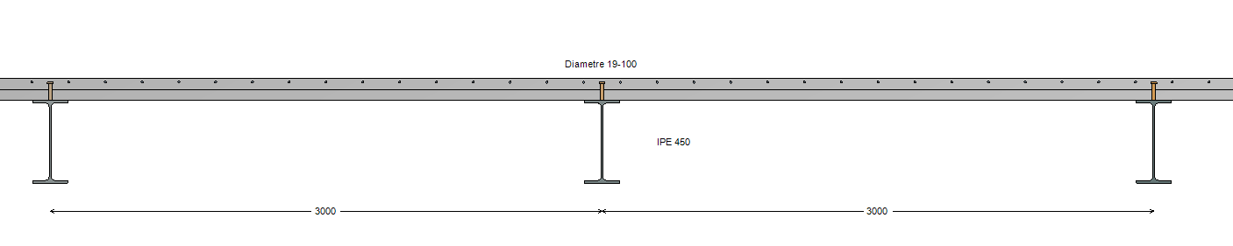
Figure 1 : Transversal view

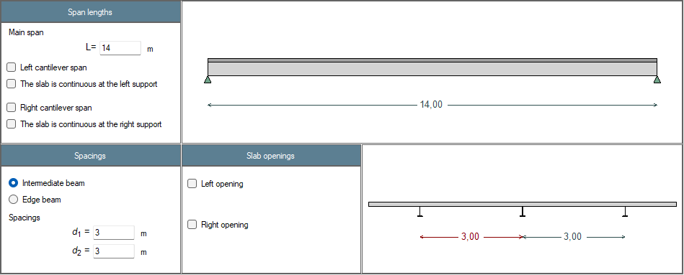
Figure 2 : Definition of the beam

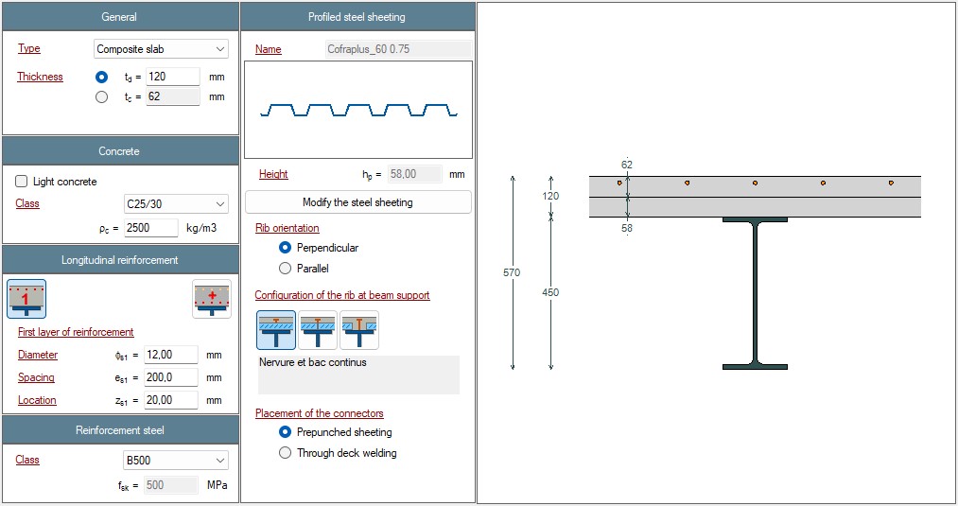
Figure 3 : Definition of the slab

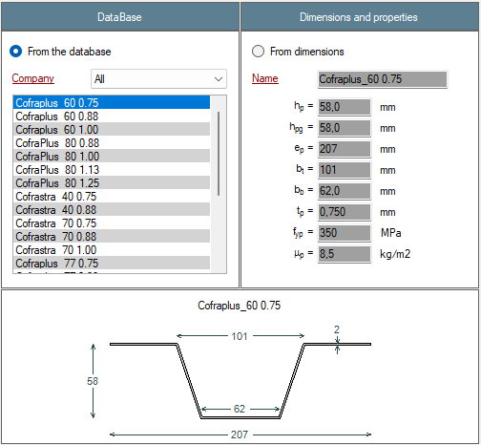
Figure 4 : Definition of the profiled steel sheeting
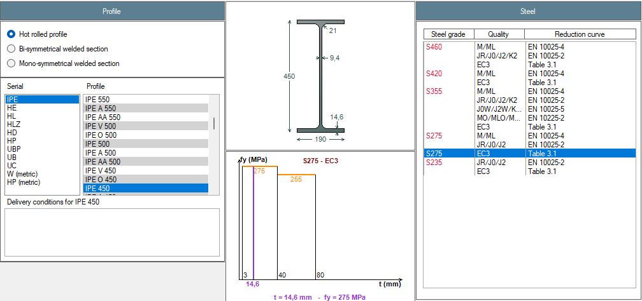
Figure 5 : Definition of the steel profile

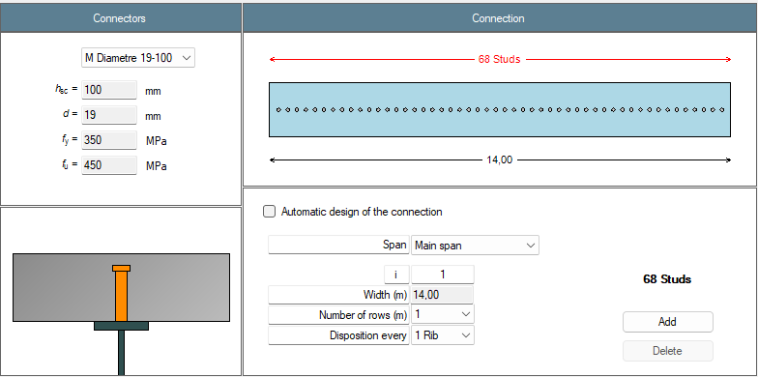
Figure 6 : Definition of the connection

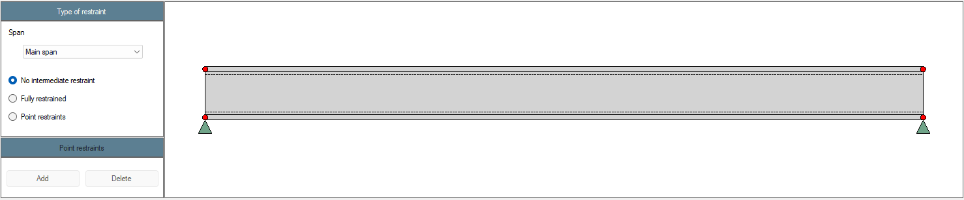
Figure 7 : Definition of the lateral restraints
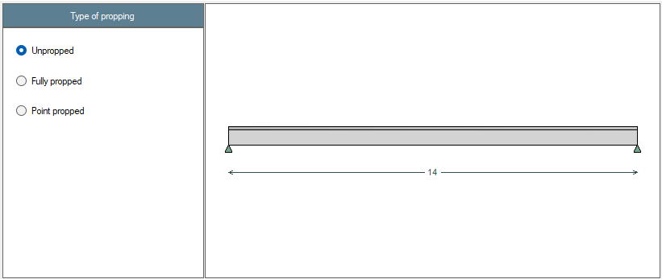
Figure 8 : Propping of the beam

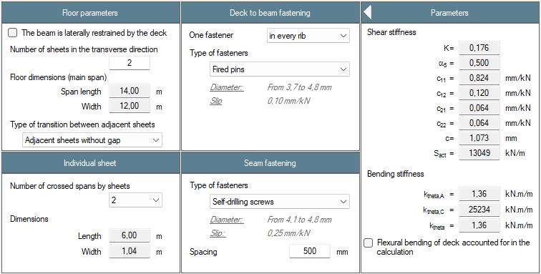
Figure 9 : Restraint of the beam by steel deck (construction phase only)

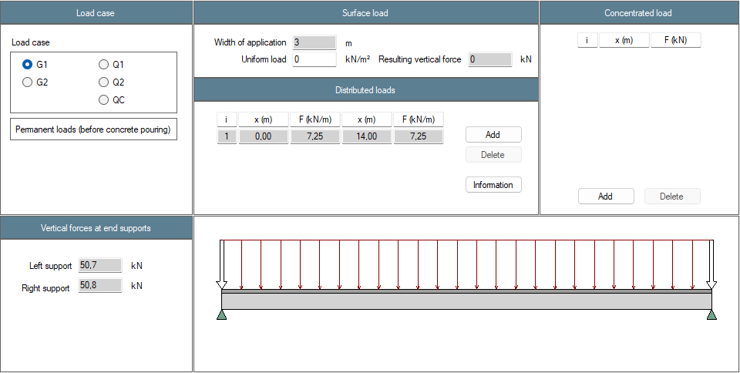
Figure 10 : Definition of the load cases – Permanent loads G1
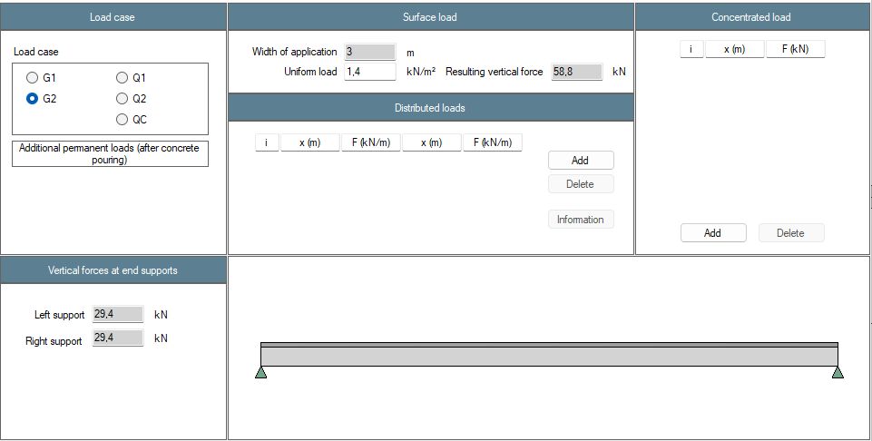
Figure 11 : Definition of the load cases – Additional permanent loads G2

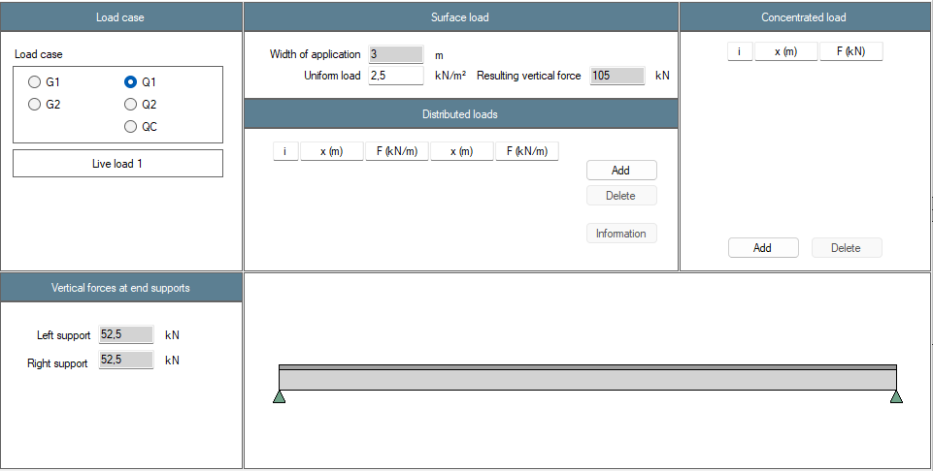
Figure 12 : Definition of the load cases – Live load 1 Q1

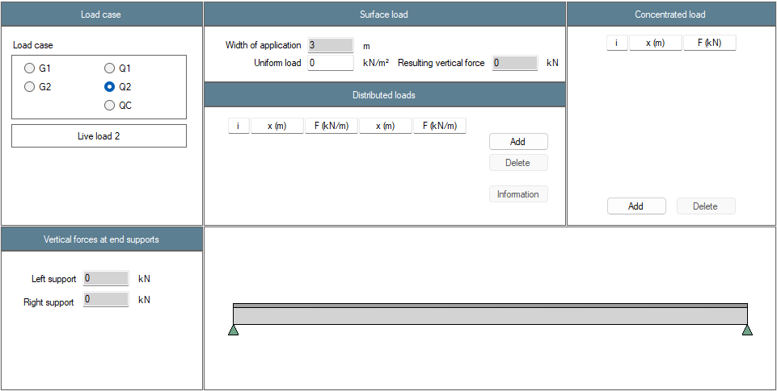
Figure 13 : Definition of the load cases – Live load 2 Q2
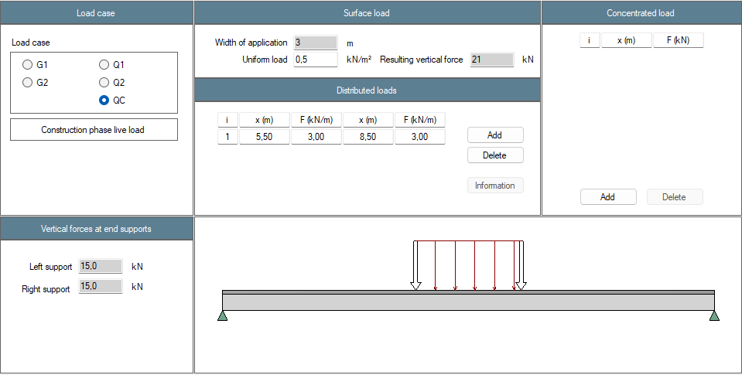
Figure 14 : Definition of the load cases – Construction phase live load QC

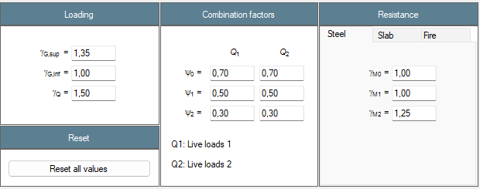
Figure 15 : Definition of national factors

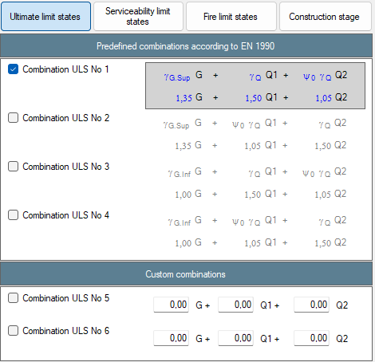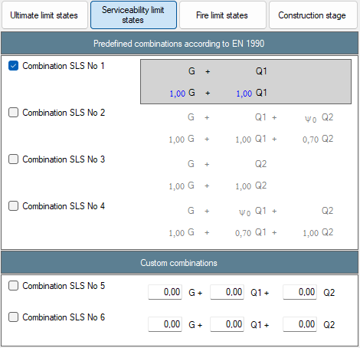
Figure 16 : Combinations – ULS and SLS
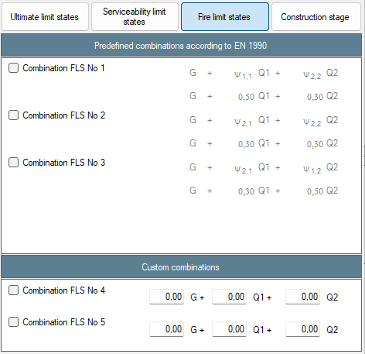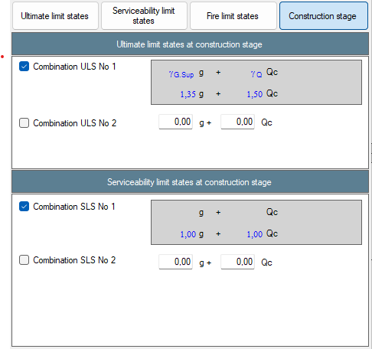
Figure 17 : Combinations – FLS and construction stage
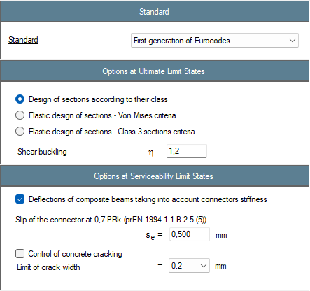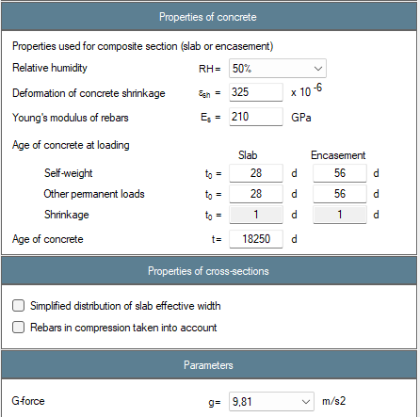
Figure 18 : Beam calculation options
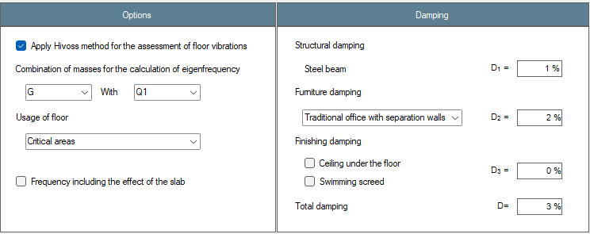
Figure 19 : Floor vibrations parameters

Results
Résultats | Reference | ABCPMX | Dev.
Cross-sectional area : $A$ = (cm²) | 98.8 | 98.8 | 0.00%
Shear area : $A_{v}$ = (cm²) | 50.9 | 50.8 | 0.20%
Moment of inertia about y-y axis : $I_{y}$ = (cm⁴) | 33 740 | 33 743 | 0.01%
Moment of inertia about z-z axis : $I_{z}$ = (cm⁴) | 1 676 | 1 672 | 0.24%
Elastic section modulus about y-y axis : $W_{el,y}$ = (cm³) | 1 500 | 1 500 | 0.00%
Elastic section modulus about z-z axis : $W_{el,z}$ = (cm³) | 176 | 176 | 0.00%
Plastic section modulus about y-y axis : $W_{pl,y}$ = (cm³) | 1 702 | 1 702 | 0.00%
Plastic section modulus about z-z axis : $W_{pl,z}$ = (cm³) | 276 | 272.8 | 1.17%
Torsional moment : $I_{t}$ = (cm⁴) | 66.66 | 66.75 | 0.13%
Warping moment : $I_{w}$ = (cm⁶) | 780 739 | 791 005 | 1.30%
Linear mass : $m_{lin}$ = (kg/ml) | 77.6 | 77.6 | 0.00%
Mass : $m$ = (kg) | 1086 | 1 086 | 0.00%
Total paint surface : $S$ = (cm²) | 224 700 | 224 721 | 0.01%
Paint surface (without upper face) : $S$ = (cm²) | 198 100 | 198 121 | 0.01%
Massiveness : $M$ = (m⁻¹) | 162 | 162.4 | 0.25%
Massiveness (without upper face) : $M$ = (m⁻¹) | 143 | 143.2 | 0.14%
Nominal yield strenght : $f_{y}$ = (MPa) | 275 | 275 | 0.00%
Young’s modulus : $E$ = (MPa) | 210 000 | 210 000 | 0.00%
Density : $ρ$ = (kg/m³) | 7 850 | 7 850 | 0.00%
Tensile resistance : $N_{t,Rd}$ = (kN) | 2 717 | 2 718 | 0.04%
Shear resistance : $V_{pl,Rd}$ = (kN) | 807 | 807 | 0.00%
Plastic moment resistant : $M_{pl,Rd}$ = (kN.m) | 468 | 468 | 0.00%
Elastic moment resistant : $M_{el,Rd}$ = (kN.m) | 412.5 | 412 | 0.12%
Section class for bending : | 1 | 1 | 0.00%
Section class for compression : | 4 | 4 | 0.00%
Shear buckling resistance : $h_{w}/t_{w}$ = | 40.3 | 40.3 | 0.00%
Shear buckling resistance : $72ε/η$ = | 55.5 | 55.5 | 0.00%
Verification of web buckling necessary ? | No | No | OK
Table 1: Steel profile
Résultats | Reference | ABCPMX | Dev.
Notional size (EN 1992-1-1 Annex B) : $h_{\text{0}}=$ (mm) | 124 | 124 | 0.00%
Char. value of the compression strenght : $f_{\text{ck}}=$ (MPa) | 25 | 25 | 0.00%
Mean value of compression strenght : $f_{\text{cm}}=$ (MPa) | 33 | 33 | 0.00%
Mean tensile strenght : $f_{\text{ctm}}=$ (MPa) | 2.56 | 2.56 | 0.00%
Mean secant modulus of elasticity : $E_{\text{cm}}=$ (MPa) | 31 476 | 31 476 | 0.00%
Sec. moment of area per unit of width : $I_{\text{pu}}=$ (cm⁴/m) | 44.37 | 44.37 | 0.00%
Shear resistance : $P_{Rd}=$ (kN) | 52.9 | 52.9 | 0.00%
Reduction factor : $k_{t}$ = | 0.71 | 0.71 | 0.00%
Table 2: Slab
Résultats | Reference | ABCPMX | Dev.
Effective width of the slab : $b_{eff}=$ (m) | 3,0 | 3,0 | 0.00%
Modular ratio : $n(G_{1})=$ | $$∞$$ | $$∞$$ | 0.00%
Modular ratio : $n(G_{2})=$ | 27.5 | 27.5 | 0.00%
Modular ratio : $n(Q_{1})=$ | 6.67 | 6.67 | 0.00%
Modular ratio : $n(Q_{c})=$ | $$∞$$ | $$∞$$ | 0.00%
Modular ratio : $n\left(SHC\right)=$ | 26.1 | 26.1 | 0.00%
Moment of inertia about y-y axis : $I_{el,y}(n=6.67)$ (cm⁴) | 106 570 | 106 571 | 0.00%
Moment of inertia about y-y axis : $I_{el,y}\left(n=26.1\right)$ (cm⁴) | 74 820 | 74 821 | 0.00%
Moment of inertia about y-y axis : $I_{el,y}\left(n=27.5\right)$ (cm⁴) | 73 533 | 73 534 | 0.00%
Moment of inertia about y-y axis : $I_{el,y}(n=∞)$ (cm⁴) | 33 742 | 33 743 | 0.00%
Elastic neutral axis : $z_{el,y}(n=6.67)$ (mm) | 6.83 | 6.82 | 0.15%
Elastic neutral axis : $z_{el,y}(n=26.1)$ (mm) | -93.4 | -93.4 | 0.00%
Elastic neutral axis : $z_{el,y}(n=27.5)$ (mm) | -97.5 | -97.5 | 0.00%
Elastic neutral axis : $z_{el,y}(n=∞)$ (mm) | -225 | -225 | 0.00%
Plastic resistance to bending moment : $M_{pl,Rd}$ (kN.m) | 846 | 846 | 0.00%
Table 3: Section properties at mid-span

Résultats | Reference | ABCPMX | Dev.
Shear force : $V(G_{1})=$ (kN) | 50.8 | 50.8 | 0.00%
Bending moment : $M(G_{1})=$ (kN.m) | 178 | 178 | 0.00%
Shear force : $V(G_{2})=$ (kN) | 29.4 | 29.4 | 0.00%
Bending moment : $M(G_{2})=$ (kN.m) | 103 | 103 | 0.00%
Shear force : $V(Q_{1})=$ (kN) | 52.5 | 52.5 | 0.00%
Bending moment : $M(Q_{1})=$ (kN.m) | 184 | 184 | 0.00%
Shear force : $V(Q_{c})=$ (kN) | 15 | 15 | 0.00%
Bending moment : $M(Q_{c})=$ (kN.m) | 64.9 | 64.9 | 0.00%
Table 4: Analysis

Résultats | Reference | ABCPMX | Dev.
Resistance to bending moment : $Γ_{M}=$ | 0.84 | 0.84 | 0.00%
Resistance to shear force : $Γ_{V}=$ | 0.23 | 0.23 | 0.00%
Resistance to MV interaction : $Γ_{MV}=$ | 0.84 | 0.84 | 0.00%
Degree of shear connection : $η=$ | 0.68 | 0.68 | 0.00%
Minimum degree of connection : $η_{min}=$ | 0.57 | 0.57 | 0.00%
Longitudinal shear force : $τ_{Ed}=$ (MPa) | 2.06 | 2.06 | 0.00%
Min. compression strut inclination angle : $θ_{f,min}=$ (°) | 27 | 27 | 0.00%
Resistance of the compression strut : $Γ_{sf} =$ | 0.57 | 0.57 | 0.00%
Area of reinf. by length unit : $A_{sf}/s_{f} =$ (cm²/m) | 0 | 0 | 0.00%
Table 5: ULS at final stage

Résultats | Reference | ABCPMX | Dev.
Resistance to bending moment : $Γ_{M}=$ | 0.72 | 0.72 | 0.00%
Resistance to shear force : $Γ_{V}=$ | 0.11 | 0.11 | 0.00%
Table 6: ULS at construction stage

Résultats | Reference | ABCPMX | Dev.
Deflection : $δ(G_{1})$ (mm) | 51.2 | 51.2 | 0.00%
Deflection : $δ\left(G_{2}\right)$ (mm) | 13.6 | 13.6 | 0.00%
Deflection : $δ(Q_{1})$ (mm) | 16.8 | 16.8 | 0.00%
Deflection : $δ\left(SHC\right)$ (mm) | 13.8 | 13.9 | 0.72%
Deflection : $δ\left(SLS\right)$ (mm) | 95.5 | 95.6 | 0.10%
Eigen frequency : $f\left(G+0.2Q_{1}\right)$ (Hz) | 3.3 | 3.3 | 0.00%
Table 7: SLS assuming full connection

Test case 2: Simply supported composite beam with partial encasement during its construction phase (RCM 2023-3)
This test is based on the RCM review n°2023-3. It deals with a simple supported composite beam with a composite slab and partial encasement during its construction phase. Because the calculation method of the software is more accurate, some values of the review may not match perfectly.

Input data
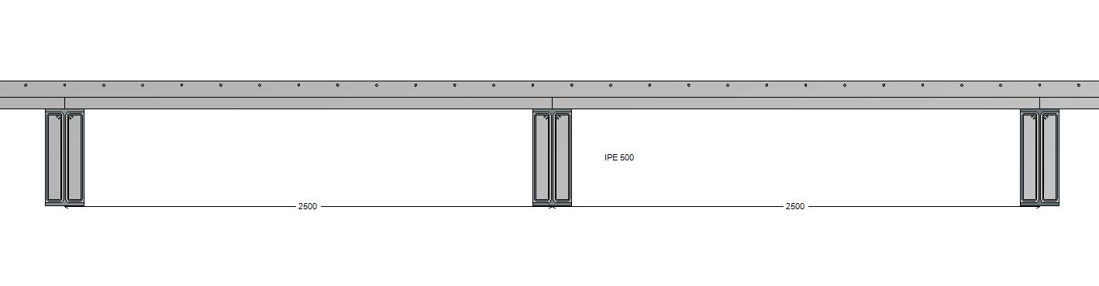
Figure 20 : Transversal view

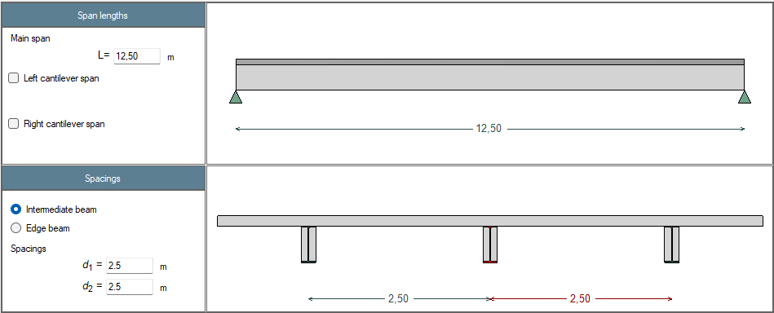
Figure 21 : Definition of the beam

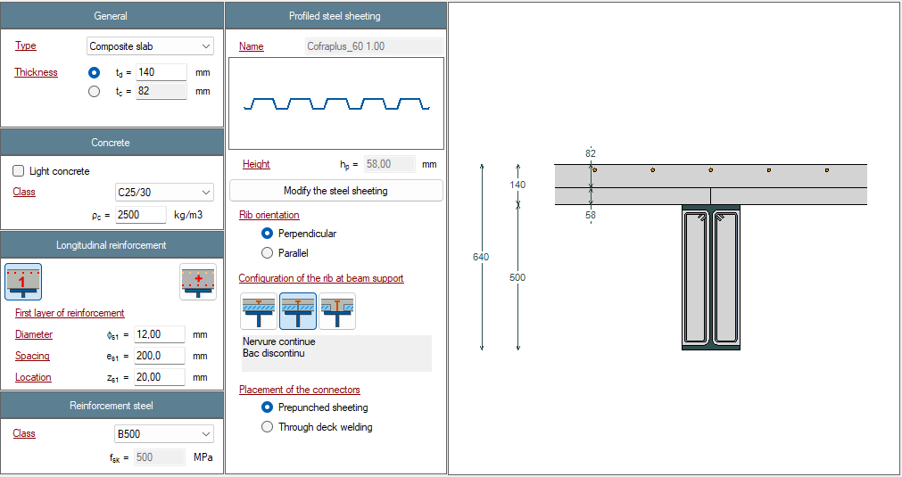
Figure 22 : Definition of the slab

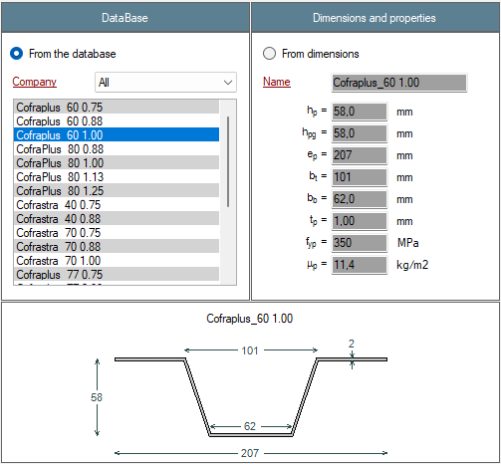
Figure 23 : Definition of the profiled steel sheeting
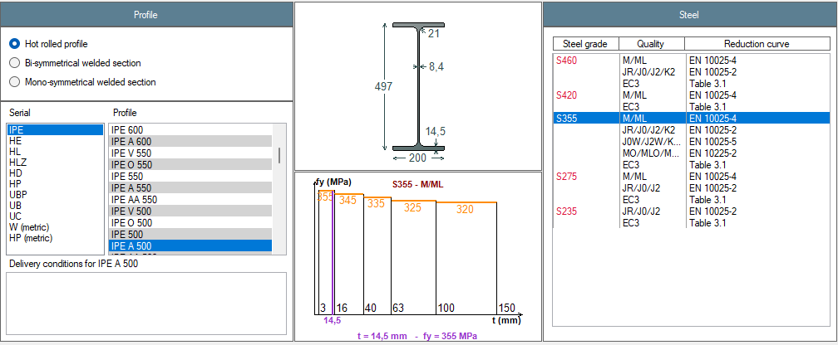
Figure 24 : Definition of the steel profile

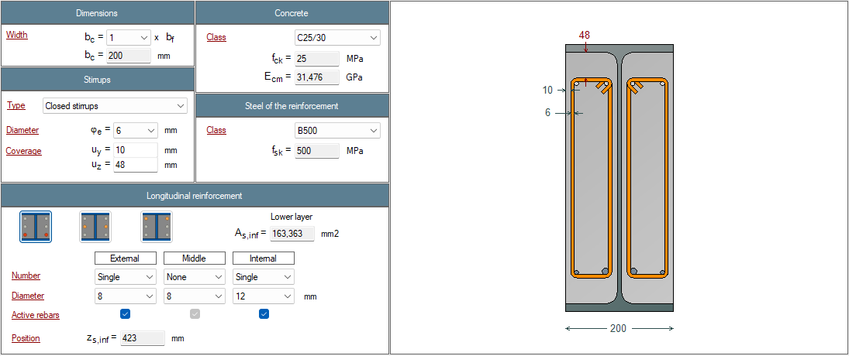
Figure 24 : Definition of the partial encasement

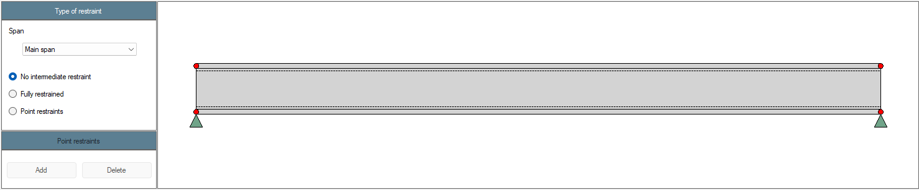
Figure 25 : Definition of the lateral restraints

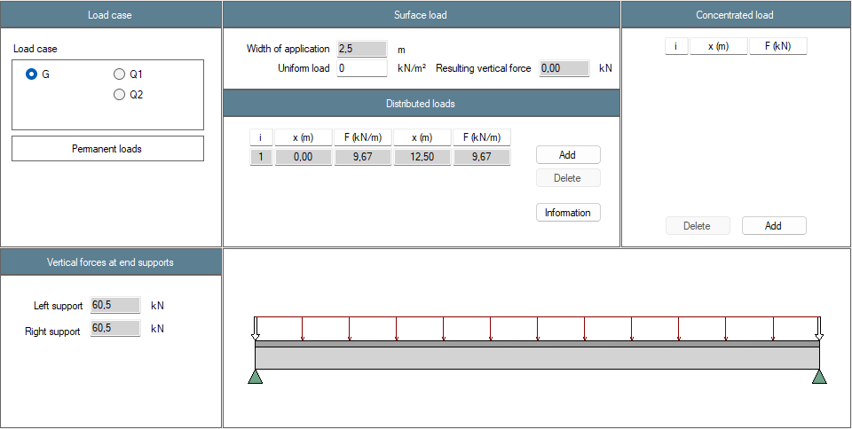
Figure 26 : Definition of the load cases – Permanent loads G1

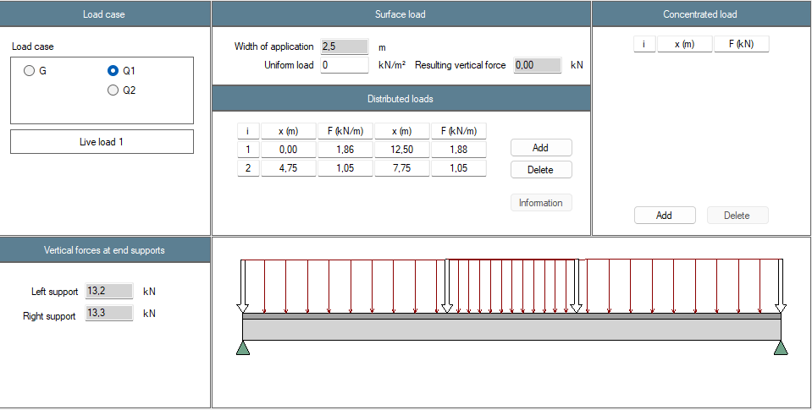
Figure 27 : Definition of the load cases – Live load 1 Q1

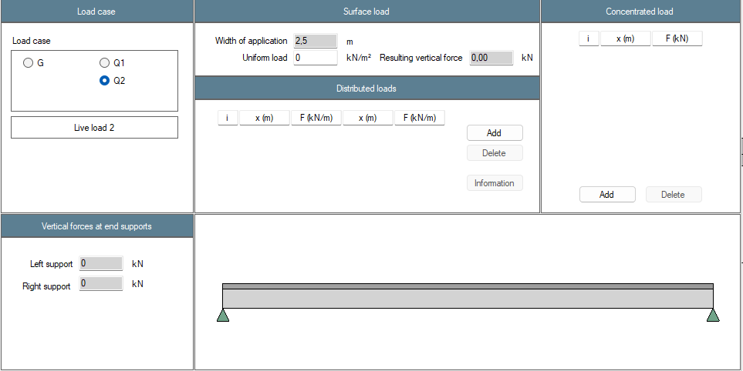
Figure 28 : Definition of the load cases – Live load 2 Q2

Figure 29 : Definition of national factors

Figure 30 : Combinations – ULS and SLS
Figure 31 : Combinations – FLS
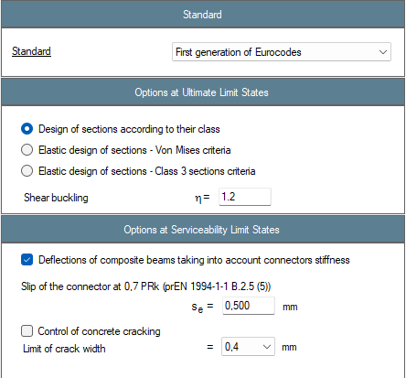
Figure 32 : Beam calculation options
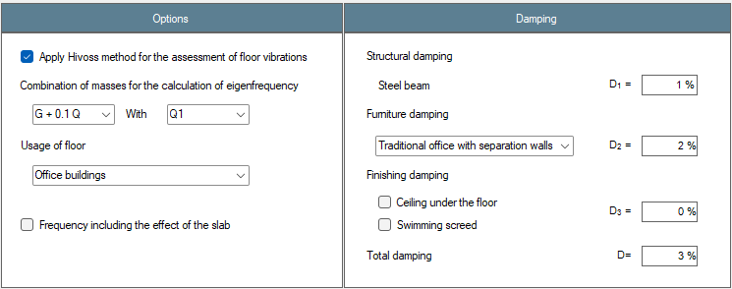
Figure 33 : Floor vibrations parameters

Results
Résultats | Reference | ABCPMX | Dev.
Cross-sectional area : $A$ = (cm²) | 101.3 | 101.1 | 0.15%
Shear area : $A_{v}$ = (cm²) | 50.6 | 50.4 | 0.32%
Moment of inertia about y-y axis : $I_{y}$ = (cm⁴) | 43 014 | 42 933 | 0.19%
Moment of inertia about z-z axis : $I_{z}$ = (cm⁴) | 1 940 | 1 936 | 0.18%
Elastic section modulus about y-y axis : $W_{el,y}$ = (cm³) | 1 731 | 1 728 | 0.17%
Elastic section modulus about z-z axis : $W_{el,z}$ = (cm³) | 194.0 | 193.6 | 0.18%
Plastic section modulus about y-y axis : $W_{pl,y}$ = (cm³) | 1 950 | 1 946 | 0.18%
Plastic section modulus about z-z axis : $W_{pl,z}$ = (cm³) | 301.7 | 298.3 | 1.15%
Torsional moment : $I_{t}$ = (cm⁴) | 64.18 | 64.28 | -0.16%
Warping moment : $I_{w}$ = (cm⁶) | 1 113 252 | 1 125 230 | -1.06%
Linear mass : $m_{lin}$ = (kg/ml) | 79.5 | 74.9 | 6.12%
Mass : $m$ = (kg) | 994 | 992 | 0.16%
Total paint surface : $S$ = (cm²) | 217 643 | 217 643 | 0.00%
Paint surface (without upper face) : $S$ = (cm²) | 192 643 | 192 643 | 0.00%
Massiveness : $M$ = (m⁻¹) | 172.0 | 172.2 | -0.14%
Massiveness (without upper face) : $M$ = (m⁻¹) | 152.2 | 152.4 | -0.13%
Nominal yield strenght : $f_{y}$ = (MPa) | 355 | 355 | 0.00%
Young’s modulus : $E$ = (MPa) | 210 000 | 210 000 | 0.00%
Density : $ρ$ = (kg/m³) | 7 850 | 7 850 | 0.00%
Tensile resistance : $N_{t,Rd}$ = (kN) | 3 595 | 3 589 | 0.15%
Shear resistance : $V_{pl,Rd}$ = (kN) | 1 036 | 1 033 | 0.32%
Plastic moment resistant : $M_{pl,Rd}$ = (kN.m) | 692 | 691 | 0.16%
Elastic moment resistant : $M_{el,Rd}$ = (kN.m) | 614 | 613 | 0.24%
Section class for bending : | 1 | 1 | 0.00%
Section class for compression : | 4 | 4 | 0.00%
Shear buckling resistance : $h_{w}/t_{w}$ = | 50.7 | 50.7 | 0.00%
Shear buckling resistance : $124ε$ = | 101 | 101 | 0.00%
Verification of web buckling necessary? | No | No | OK
Table 8: Steel profile

Résultats | Reference | ABCPMX | Dev.
Notional size (EN 1992-1-1 Annex B) : $h_{\text{0}}=$ (mm) | 191 | 191 | 0.00%
Char. value of the compression strenght : $f_{\text{ck}}=$ (MPa) | 25 | 25 | 0.00%
Mean value of compression strenght : $f_{\text{cm}}=$ (MPa) | 33 | 33 | 0.00%
Mean tensile strenght : $f_{\text{ctm}}=$ (MPa) | 2.56 | 2.56 | 0.00%
Mean secant modulus of elasticity : $E_{\text{cm}}=$ (MPa) | 31 476 | 31 476 | 0.00%
Table 9: Partial encasement

Résultats | Reference | ABCPMX | Dev.
Notional size (EN 1992-1-1 Annex B) : $h_{\text{0}}=$ (mm) | 210 | 210 | 0.00%
Char. value of the compression strenght : $f_{\text{ck}}=$ (MPa) | 25 | 25 | 0.00%
Mean value of compression strenght : $f_{\text{cm}}=$ (MPa) | 33 | 33 | 0.00%
Mean tensile strenght : $f_{\text{ctm}}=$ (MPa) | 2.56 | 2.56 | 0.00%
Mean secant modulus of elasticity : $E_{\text{cm}}=$ (MPa) | 31 476 | 31 476 | 0.00%
Sec. moment of area per unit of width : $I_{\text{pu}}=$ (cm⁴/m) | 60.08 | 60.08 | 0.00%
Table 10: Slab
Résultats | Reference | ABCPMX | Dev.
Modular ratio : $n_{enrobage}(G_{1})=$ | 23.7 | 23.7 | 0.00%
Modular ratio : $n_{enrobage}(Q_{c})=$ | 6.67 | 6.67 | 0.00%
Moment of inertia about y-y axis : $I_{el,y}(n=6.67)$ (cm⁴) | 53 002 | 52 921 | 0.15%
Moment of inertia about y-y axis : $I_{el,y}\left(n=23.7\right)$ (cm⁴) | 47 200 | 47 128 | -0.15%
Moment of inertia about y-y axis : $I_{el,y}\left(n=24.7\right)$ (cm⁴) | 47 083 | 47 005 | -0.17%
Elastic neutral axis : $z_{el,y}(n=6.67)$ (mm) | 205 | 205 | 0.00%
Elastic neutral axis : $z_{el,y}(n=23.7)$ (mm) | 235 | 235 | 0.00%
Elastic neutral axis : $z_{el,y}(n=24.7)$ (mm) | 236 | 236 | 0.00%
Plastic resistance to bending moment : $M_{pl,Rd}$ (kN.m) | 777 | 775 | 0.26%
Table 11: Section properties at mid-span

Résultats | Reference | ABCPMX | Dev.
Shear force : $V(G_{1})=$ (kN) | 60.5 | 60.5 | 0.00%
Bending moment : $M(G_{1})=$ (kN.m) | 189 | 189 | 0.00%
Shear force : $V(Q_{c})=$ (kN) | 13.3 | 13.3 | 0.00%
Bending moment : $M(Q_{c})=$ (kN.m) | 45.3 | 45.4 | -0.22%
Table 12: Analysis

Résultats | Reference | ABCPMX | Dev.
Resistance to bending moment : $Γ_{M}=$ | 0.42 | 0.42 | 0.00%
Resistance to shear force : $Γ_{V}=$ | 0.10 | 0.10 | 0.00%
Resistance to MV interaction : $Γ_{MV}=$ | 0.42 | 0.42 | 0.00%
Critical moment to lateral torsional buckling : $M_{cr}$ (kN.m) | 903 | 914 | -1.20%
Resistance to lateral torsional buckling : $Γ_{LT}=$ | 0.66 | 0.63 | 4.76%
Table 13: ULS

Résultats | Reference | ABCPMX | Dev.
Deflection : $δ(G_{1})$ (mm) | 31.0 | 31.1 | -0.32%
Deflection : $δ(Q_{c})$ (mm) | 6.5 | 6.5 | 0.00%
Deflection : $δ\left(SLS\right)$ (mm) | 37.5 | 37.6 | -0.27%
Table 14: SLS

Test case 3: Simply supported composite beam with partial encasement during its final phase (RCM 2023-4)
This test is based on the RCM review n°2023-4. It deals with a simple supported composite beam with a composite slab and partial encasement during its final phase. Because the calculation method of the software is more accurate, some values of the review may not match perfectly.

Input data
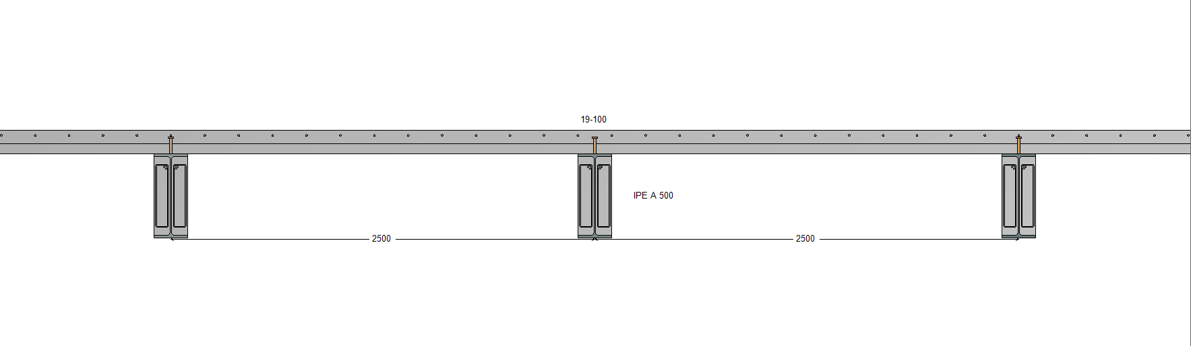
Figure 1 : Transversal view

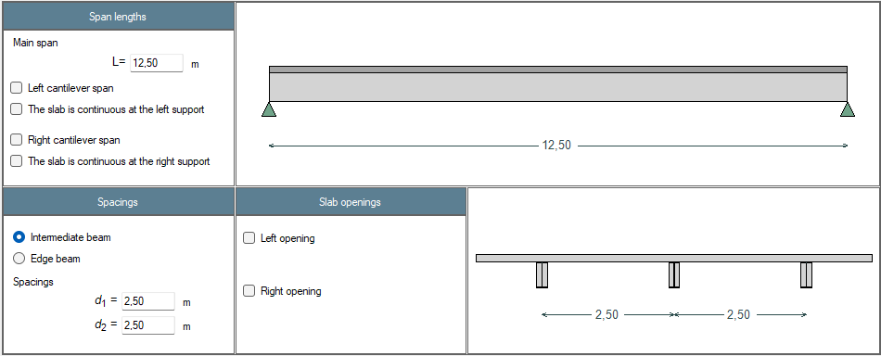
Figure 2 : Definition of the beam

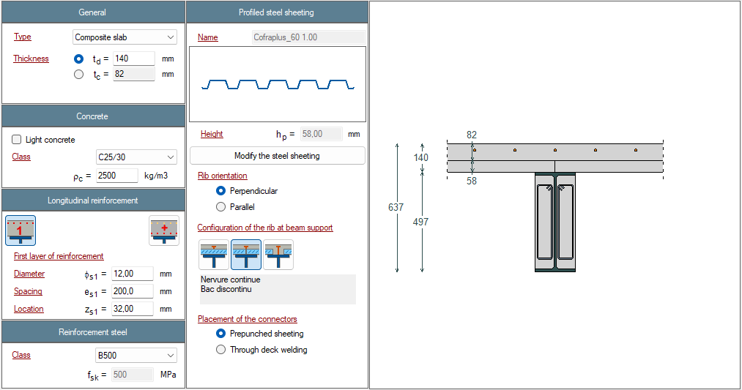
Figure 3 : Definition of the slab

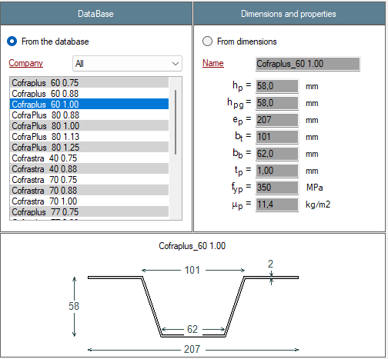
Figure 4 : Definition of the profiled steel sheeting
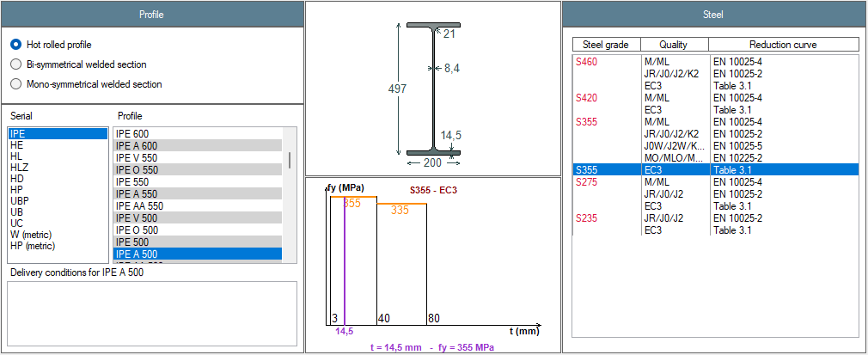
Figure 5 : Definition of the steel profile

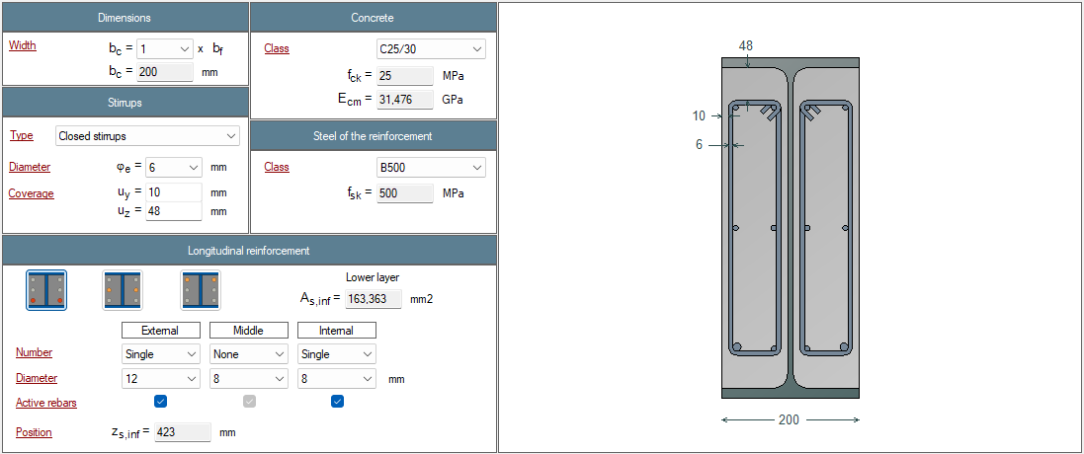
Figure 5 : Definition of the partial encasement

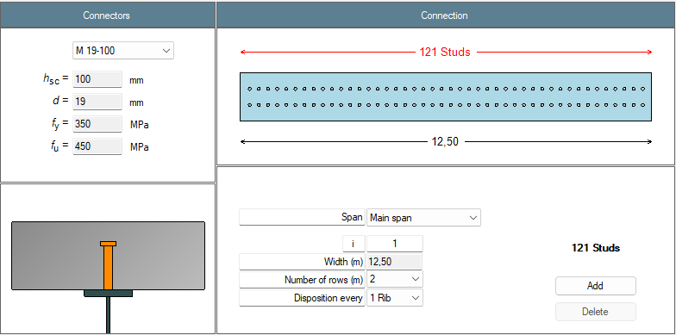
Figure 6 : Definition of the connection

Figure 7 : Definition of the lateral restraints
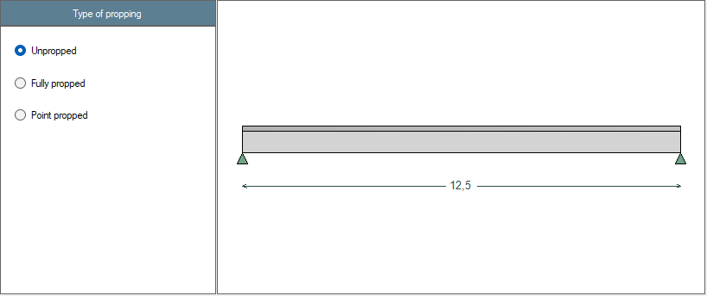
Figure 8 : Propping of the beam

Figure 9 : Restraint of the beam by steel deck (construction phase only)

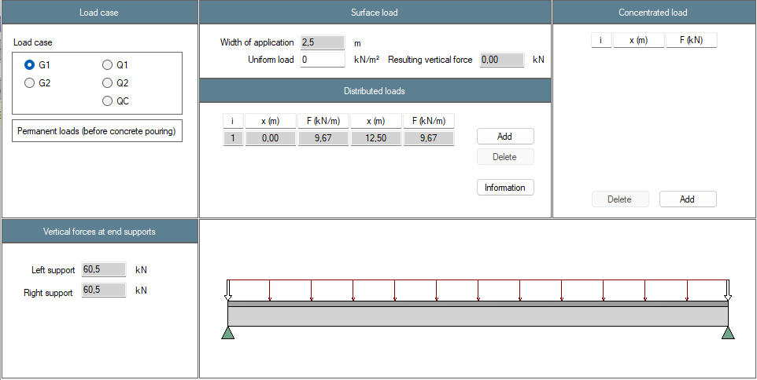
Figure 10 : Definition of the load cases – Permanent loads G1
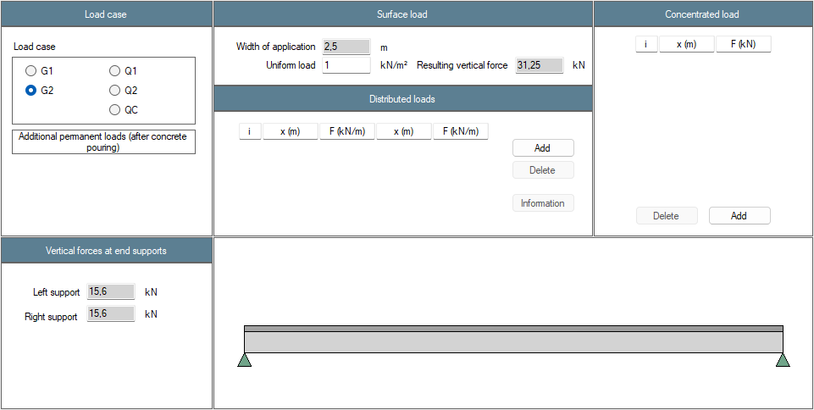
Figure 11 : Definition of the load cases – Additional permanent loads G2

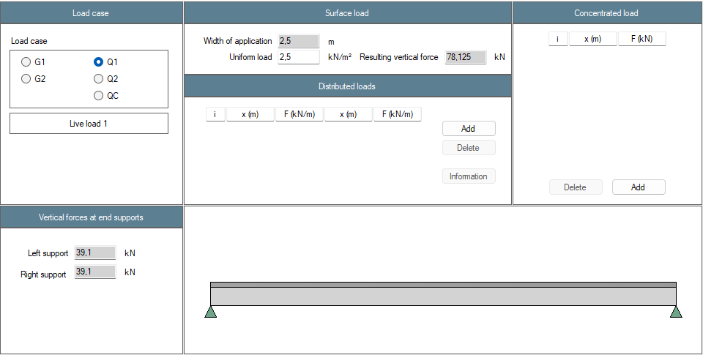
Figure 12 : Definition of the load cases – Live load 1 Q1

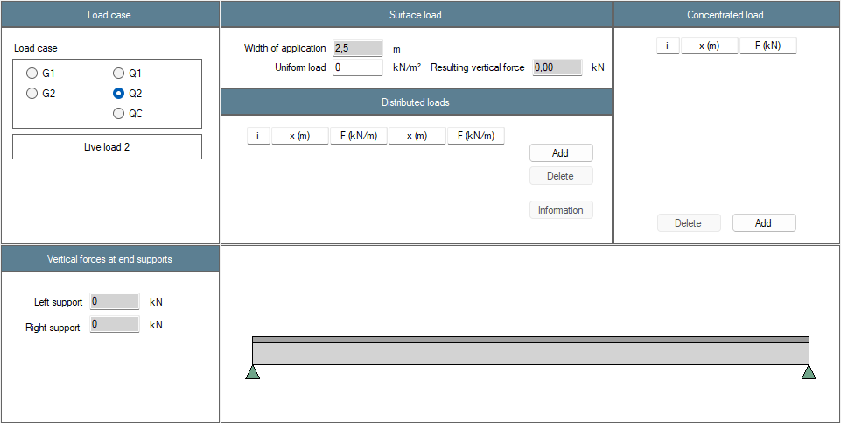
Figure 13 : Definition of the load cases – Live load 2 Q2
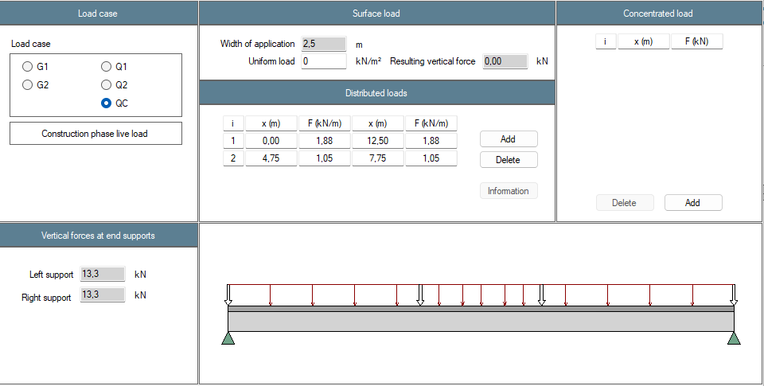
Figure 14 : Definition of the load cases – Construction phase live load QC

Figure 15 : Definition of national factors

Figure 16 : Combinations – ULS and SLS
Figure 17 : Combinations – FLS and construction stage
Figure 18 : Beam calculation options
Figure 19 : Floor vibrations parameters

Results
Résultats | Reference | ABCPMX | Dev.
Cross-sectional area : $A$ = (cm²) | 101.3 | 101.1 | 0.15%
Shear area : $A_{v}$ = (cm²) | 50.6 | 50.4 | 0.32%
Moment of inertia about y-y axis : $I_{y}$ = (cm⁴) | 43 014 | 42 933 | 0.19%
Moment of inertia about z-z axis : $I_{z}$ = (cm⁴) | 1 940 | 1 936 | 0.18%
Elastic section modulus about y-y axis : $W_{el,y}$ = (cm³) | 1 731 | 1 728 | 0.17%
Elastic section modulus about z-z axis : $W_{el,z}$ = (cm³) | 194.0 | 193.6 | 0.18%
Plastic section modulus about y-y axis : $W_{pl,y}$ = (cm³) | 1 950 | 1 946 | 0.18%
Plastic section modulus about z-z axis : $W_{pl,z}$ = (cm³) | 301.7 | 298.3 | 1.15%
Torsional moment : $I_{t}$ = (cm⁴) | 64.18 | 64.28 | -0.16%
Warping moment : $I_{w}$ = (cm⁶) | 1 113 252 | 1 125 230 | -1.06%
Linear mass : $m_{lin}$ = (kg/ml) | 79.5 | 74.9 | 6.12%
Mass : $m$ = (kg) | 994 | 992 | 0.16%
Total paint surface : $S$ = (cm²) | 217 643 | 217 643 | 0.00%
Paint surface (without upper face) : $S$ = (cm²) | 192 643 | 192 643 | 0.00%
Massiveness : $M$ = (m⁻¹) | 171.9 | 172.2 | -0.14%
Massiveness (without upper face) : $M$ = (m⁻¹) | 152.1 | 152.4 | -0.13%
Nominal yield strenght : $f_{y}$ = (MPa) | 355 | 355 | 0.00%
Young’s modulus : $E$ = (MPa) | 210 000 | 210 000 | 0.00%
Density : $ρ$ = (kg/m³) | 7 850 | 7 850 | 0.00%
Tensile resistance : $N_{t,Rd}$ = (kN) | 3 596 | 3 589 | 0.15%
Shear resistance : $V_{pl,Rd}$ = (kN) | 1 037 | 1 033 | 0.32%
Plastic moment resistant : $M_{pl,Rd}$ = (kN.m) | 692 | 691 | 0.16%
Elastic moment resistant : $M_{el,Rd}$ = (kN.m) | 614 | 613 | 0.24%
Section class for bending : | 1 | 1 | 0.00%
Section class for compression : | 4 | 4 | 0.00%
Shear buckling resistance : $h_{w}/t_{w}$ = | 50.7 | 50.7 | 0.00%
Shear buckling resistance : $72ε/η$ = | 101 | 101 | 0.00%
Verification of web buckling necessary ? | No | No | OK
Table 1: Steel profile

Résultats | Reference | ABCPMX | Dev.
Notional size (EN 1992-1-1 Annex B) : $h_{\text{0}}=$ (mm) | 191 | 191 | 0.00%
Char. value of the compression strenght : $f_{\text{ck}}=$ (MPa) | 25 | 25 | 0.00%
Mean value of compression strenght : $f_{\text{cm}}=$ (MPa) | 33 | 33 | 0.00%
Mean tensile strenght : $f_{\text{ctm}}=$ (MPa) | 2.56 | 2.56 | 0.00%
Mean secant modulus of elasticity : $E_{\text{cm}}=$ (MPa) | 31 476 | 31 476 | 0.00%
Table 9: Partial encasement

Résultats | Reference | ABCPMX | Dev.
Notional size (EN 1992-1-1 Annex B) : $h_{\text{0}}=$ (mm) | 164 | 164 | 0.00%
Char. value of the compression strenght : $f_{\text{ck}}=$ (MPa) | 25 | 25 | 0.00%
Mean value of compression strenght : $f_{\text{cm}}=$ (MPa) | 33 | 33 | 0.00%
Mean tensile strenght : $f_{\text{ctm}}=$ (MPa) | 2.56 | 2.56 | 0.00%
Mean secant modulus of elasticity : $E_{\text{cm}}=$ (MPa) | 31 476 | 31 476 | 0.00%
Sec. moment of area per unit of width : $I_{\text{pu}}=$ (cm⁴/m) | 60.08 | 60.08 | 0.00%
Shear resistance : $P_{Rd}=$ (kN) | 37.4 | 37.4 | 0.00%
Reduction factor : $k_{t}$ = | 0.50 | 0.50 | 0.00%
Table 2: Slab
Résultats | Reference | ABCPMX | Dev.
Effective width of the slab : $b_{eff}=$ (m) | 2.50 | 2.50 | 0.00%
Modular ratio : $n_{slab}(G_{1})=$ | $$∞$$ | $$∞$$ | OK
Modular ratio : $n_{encasement}(G_{1})=$ | 23.7 | 23.7 | 0.00%
Modular ratio : $n_{slab}(G_{2})=$ | 26.6 | 26.6 | 0.00%
Modular ratio : $n_{encasement}(G_{2})=$ | 23.7 | 23.7 | 0.00%
Modular ratio : $n_{slab}(Q_{1})=$ | 6.67 | 6.67 | 0.00%
Modular ratio : $n_{encasement}\left(Q_{1}\right)=$ | 6.67 | 6.67 | 0.00%
Modular ratio : $n_{slab}(Q_{c})=$ | $$∞$$ | $$∞$$ | OK
Modular ratio : $n_{encasement}\left(Q_{c}\right)=$ | 6.67 | 6.67 | 0.00%
Modular ratio : $n_{slab}\left(SHC\right)=$ | 25.2 | 25.2 | 0.00%
Modular ratio : $n_{slab}\left(SHC\right)=$ | 24.7 | 24.7 | 0.00%
Moment of inertia about y-y axis : $I_{el,y}(G_{1})$ (cm⁴) | 47 237 | 47 128 | 0.23%
Moment of inertia about y-y axis : $I_{el,y}\left(G_{2}\right)$ (cm⁴) | 99 895 | 99 778 | 0.12%
Moment of inertia about y-y axis : $I_{el,y}(Q_{1})$ (cm⁴) | 142 875 | 142 677 | 0.14%
Moment of inertia about y-y axis : $I_{el,y}(Q_{c})$ (cm⁴) | 53 094 | 52 921 | 0.33%
Moment of inertia about y-y axis : $I_{el,y}(SHC)$ (cm⁴) | 101 577 | 101 471 | 0.10 %
Elastic neutral axis : $z_{el,y}(G_{1})$ (mm) | -235 | -235 | 0.00%
Elastic neutral axis : $z_{el,y}(G_{2})$ (mm) | -102.4 | -102 | 0.39%
Elastic neutral axis : $z_{el,y}(Q_{1})$ (mm) | 9.38 | 9.51 | -1.37%
Elastic neutral axis : $z_{el,y}(Q_{c})$ (mm) | -205 | -205 | 0.00%
Elastic neutral axis : $z_{el,y}(SHC)$ (mm) | -98.1 | -97.9 | 0.20%
Plastic resistance to bending moment : $M_{pl,Rd}$ (kN.m) | 1 190 | 1 237 | -3.80%
Table 3: Section properties at mid-span

Résultats | Reference | ABCPMX | Dev.
Shear force : $V(G_{1})=$ (kN) | 60.5 | 60.5 | 0.00%
Bending moment : $M(G_{1})=$ (kN.m) | 189 | 189 | 0.00%
Shear force : $V(G_{2})=$ (kN) | 15.6 | 15.6 | 0.00%
Bending moment : $M(G_{2})=$ (kN.m) | 48.8 | 48.8 | 0.00%
Shear force : $V(Q_{1})=$ (kN) | 39.1 | 39.1 | 0.00%
Bending moment : $M(Q_{1})=$ (kN.m) | 122 | 122 | 0.00%
Shear force : $V(Q_{c})=$ (kN) | 13.3 | 13.3 | 0.00%
Bending moment : $M(Q_{c})=$ (kN.m) | 45.3 | 45.4 | -0.22%
Shear force : $V(SHC)=$ (kN) | 0 | 0 | 0.00%
Bending moment : $M(SHC)=$ (kN.m) | 112.5 | 110 | 0.00%
Shear force : $V_{Ed}=$ (kN) | 161 | 161 | 0.00%
Bending moment : $M_{Ed}=$ (kN.m) | 504 | 504 | 0.00%
Shear force : $V_{Ed,const}=$ (kN) | 102 | 102 | 0.00%
Bending moment : $M_{Ed,const}=$ (kN.m) | 323 | 323 | 0.00%
Table 4: Analysis

Résultats | Reference | ABCPMX | Dev.
Resistance to bending moment : $Γ_{M}=$ | 0.42 | 0.42 | 0.00%
Resistance to shear force : $Γ_{V}=$ | 0.16 | 0.16 | 0.00%
Resistance to MV interaction : $Γ_{MV}=$ | 0.42 | 0.42 | 0.00%
Degree of shear connection : $η=$ | 0.78 | 0.78 | 0.00%
Minimum degree of connection : $η_{min}=$ | 0.63 | 0.63 | 0.00%
Longitudinal shear force : $τ_{Ed}=$ (MPa) | 2.20 | 2.14 | 2.80%
Min. compression strut inclination angle : $θ_{f,min}=$ (°) | 27 | 27 | 0.00%
Resistance of the compression strut : $Γ_{sf} =$ | 0.61 | 0.59 | 3.39%
Area of reinf. by length unit : $A_{sf}/s_{f} =$ (cm²/m) | 2.12 | 2.05 | 3.41%
Table 5: ULS at final stage

Résultats | Reference | ABCPMX | Dev.
Resistance to bending moment : $Γ_{M}=$ | 0.42 | 0.42 | 0.00%
Resistance to shear force : $Γ_{V}=$ | 0.10 | 0.10 | 0.00%
Resistance to MV interaction : $Γ_{MV}=$ | 0.42 | 0.42 | 0.00%
Critical moment to lateral torsional buckling : $M_{cr}$ (kN.m) | 903 | 914 | -1.20%
Resistance to lateral torsional buckling : $Γ_{LT}=$ | 0.66 | 0.63 | 4.76%
Table 6: ULS at construction stage

Résultats | Reference | ABCPMX | Dev.
Deflection : $δ(G_{1})$ (mm) | 31.1 | 31.1 | 0.00%
Deflection : $δ\left(G_{2}\right)$ (mm) | 3.79 | 3.79 | 0.00%
Deflection : $δ(Q_{1})$ (mm) | 6.62 | 6.57 | 0.76%
Deflection : $δ(Q_{c})$ (mm) | 6.5 | 6.49 | 0.15%
Deflection : $δ\left(SHC\right)$ (mm) | 10.3 | 10.1 | 1.98%
Deflection : $δ\left(SLS\right)$ (mm) | 51.8 | 51.5 | 0.58%
Eigen frequency : $f\left(G+0.2Q_{1}\right)$ (Hz) | 4.6 | 4.72 | -2.54%
Table 7: SLS assuming full connection

Test case 4: Simply supported steel beam laterally restrained during its construction phase (RCM 2022-2)
This test is based on the RCM review n°2022-3. It deals with a simple supported steel beam which is laterally restrained during its construction phase. Because the calculation method of the software is more accurate, some values of the review may not match perfectly.

Input data
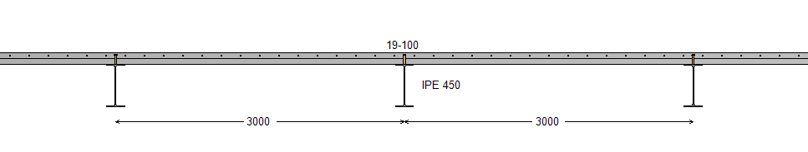
Figure 1 : Transversal view

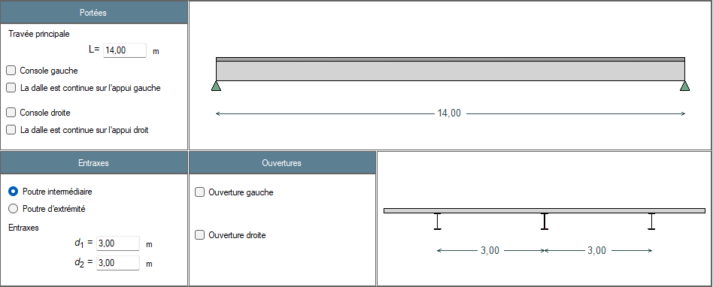
Figure 2 : Definition of the beam

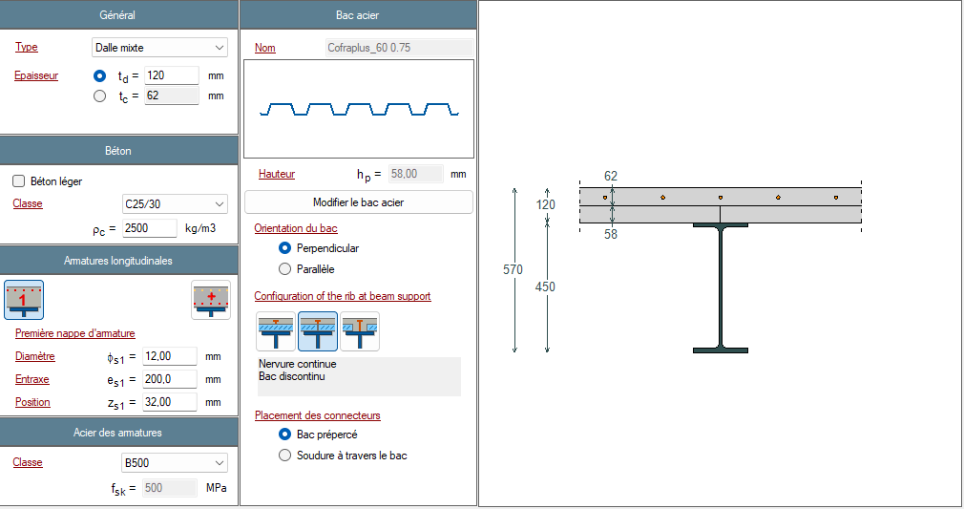
Figure 3 : Definition of the slab

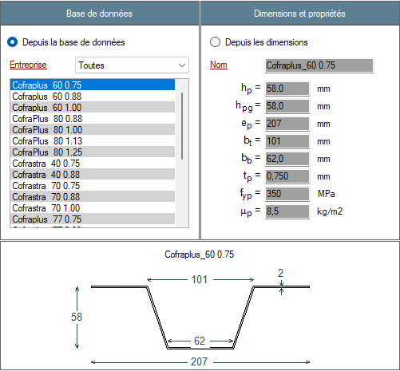
Figure 4 : Definition of the profiled steel sheeting
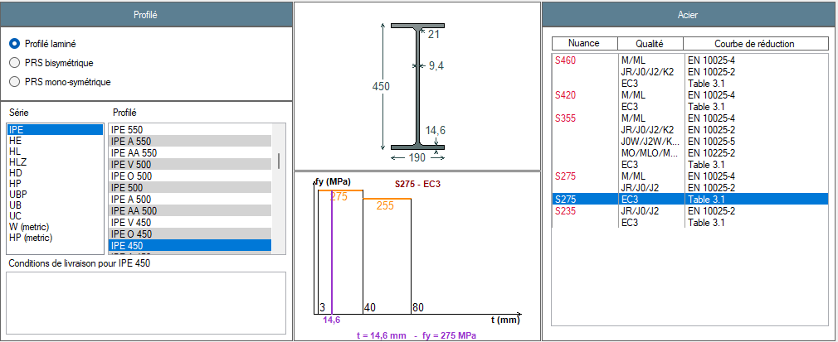
Figure 5 : Definition of the steel profile

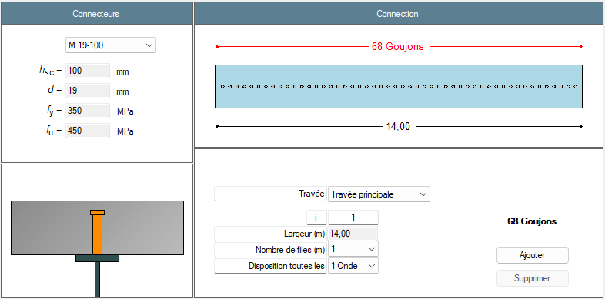
Figure 6 : Definition of the connection

Figure 7 : Definition of the lateral restraints
Figure 8 : Propping of the beam

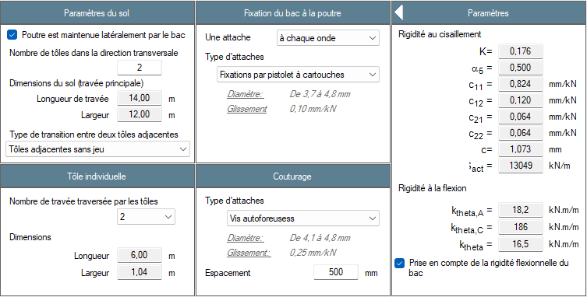
Figure 9 : Restraint of the beam by steel deck (construction phase only)

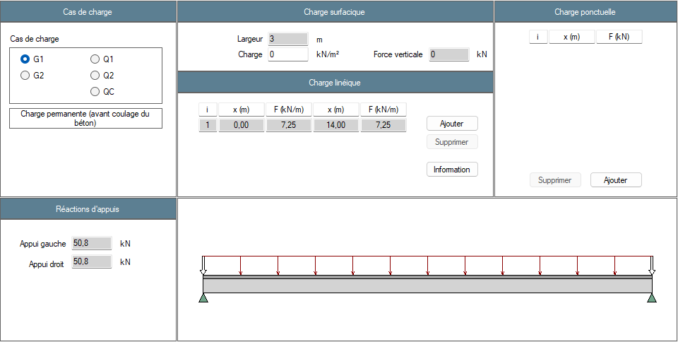
Figure 10 : Definition of the load cases – Permanent loads G1
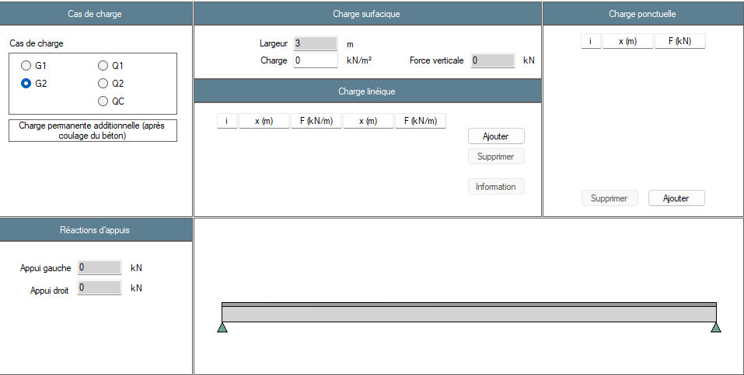
Figure 11 : Definition of the load cases – Additional permanent loads G2

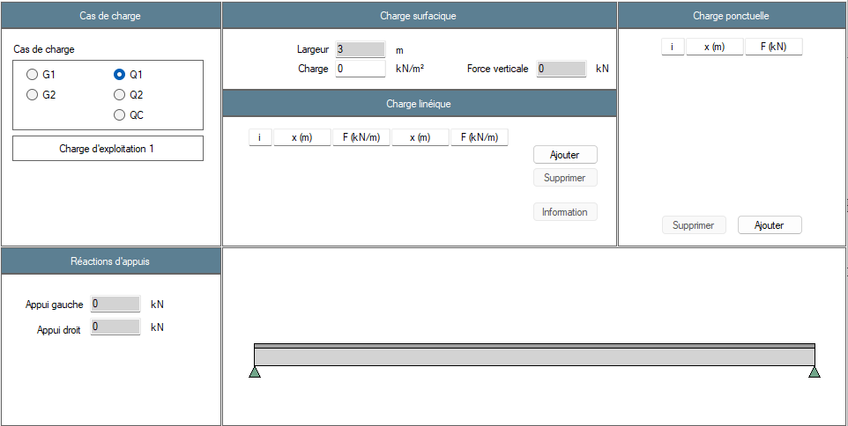
Figure 12 : Definition of the load cases – Live load 1 Q1

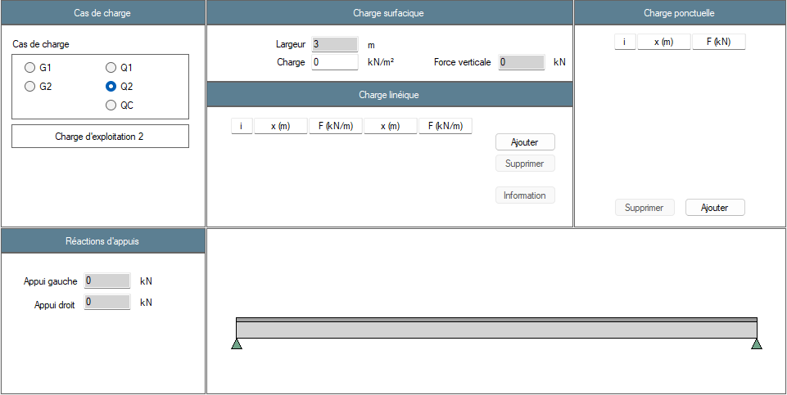
Figure 13 : Definition of the load cases – Live load 2 Q2
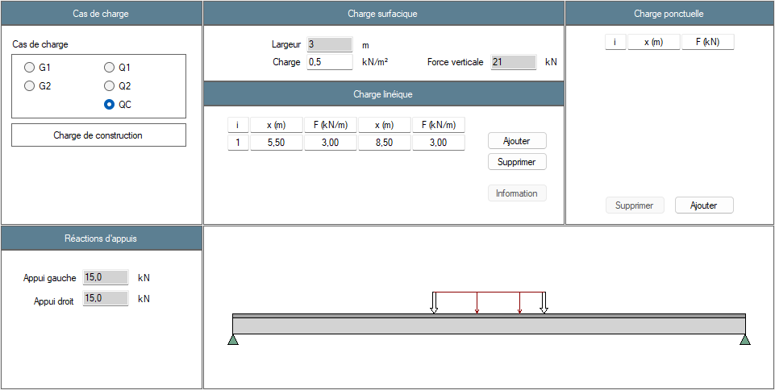
Figure 14 : Definition of the load cases – Construction phase live load QC

Figure 15 : Definition of national factors

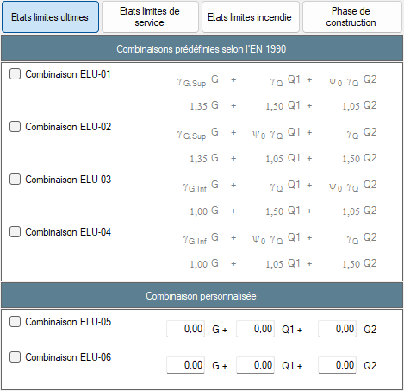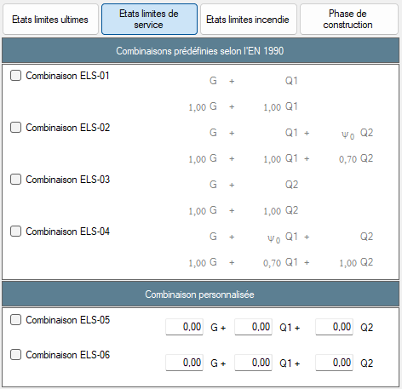
Figure 16 : Combinations – ULS and SLS
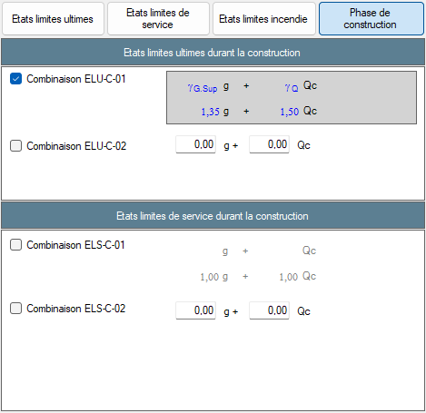
Figure 17 : Combinations – FLS and construction stage
Figure 18 : Beam calculation options
Figure 19 : Floor vibrations parameters

Results
Résultats | Reference | ABCPMX | Dev.
Cross-sectional area : $A$ = (cm²) | 98.8 | 98.8 | 0.00%
Shear area : $A_{v}$ = (cm²) | 50.9 | 50.8 | 0.20%
Moment of inertia about y-y axis : $I_{y}$ = (cm⁴) | 33 740 | 33 743 | 0.01%
Moment of inertia about z-z axis : $I_{z}$ = (cm⁴) | 1 676 | 1 672 | 0.24%
Elastic section modulus about y-y axis : $W_{el,y}$ = (cm³) | 1 500 | 1 500 | 0.00%
Elastic section modulus about z-z axis : $W_{el,z}$ = (cm³) | 176 | 176 | 0.00%
Plastic section modulus about y-y axis : $W_{pl,y}$ = (cm³) | 1 702 | 1 702 | 0.00%
Plastic section modulus about z-z axis : $W_{pl,z}$ = (cm³) | 276 | 272.8 | 1.17%
Torsional moment : $I_{t}$ = (cm⁴) | 66.66 | 66.75 | 0.13%
Warping moment : $I_{w}$ = (cm⁶) | 780 739 | 791 005 | 1.30%
Linear mass : $m_{lin}$ = (kg/ml) | 77.6 | 77.6 | 0.00%
Mass : $m$ = (kg) | 1086 | 1 086 | 0.00%
Total paint surface : $S$ = (cm²) | 224 700 | 224 721 | 0.01%
Paint surface (without upper face) : $S$ = (cm²) | 198 100 | 198 121 | 0.01%
Massiveness : $M$ = (m⁻¹) | 162 | 162.4 | 0.25%
Massiveness (without upper face) : $M$ = (m⁻¹) | 143 | 143.2 | 0.14%
Nominal yield strenght : $f_{y}$ = (MPa) | 275 | 275 | 0.00%
Young’s modulus : $E$ = (MPa) | 210 000 | 210 000 | 0.00%
Density : $ρ$ = (kg/m³) | 7 850 | 7 850 | 0.00%
Tensile resistance : $N_{t,Rd}$ = (kN) | 2 717 | 2 718 | 0.04%
Shear resistance : $V_{pl,Rd}$ = (kN) | 807 | 807 | 0.00%
Plastic moment resistant : $M_{pl,Rd}$ = (kN.m) | 468 | 468 | 0.00%
Elastic moment resistant : $M_{el,Rd}$ = (kN.m) | 412.5 | 412 | 0.12%
Section class for bending : | 1 | 1 | 0.00%
Section class for compression : | 4 | 4 | 0.00%
Shear buckling resistance : $h_{w}/t_{w}$ = | 40.3 | 40.3 | 0.00%
Shear buckling resistance : $72ε/η$ = | 55.5 | 55.5 | 0.00%
Verification of web buckling necessary ? | No | No | OK
Table 1: Steel profile

Résultats | Reference | ABCPMX | Dev.
Shear force : $V(G_{1})=$ (kN) | 50.8 | 50.8 | 0.00%
Bending moment : $M(G_{1})=$ (kN.m) | 178 | 178 | 0.00%
Shear force : $V(Q_{c})=$ (kN) | 15 | 15 | 0.00%
Bending moment : $M(Q_{c})=$ (kN.m) | 64.8 | 64.8 | 0.00%
Shear force : $V_{Ed}=$ (kN) | 91 | 91 | 0.00%
Bending moment : $M_{Ed}=$ (kN.m) | 337 | 337 | 0.00%
Table 4: Analysis

Résultats | Reference | ABCPMX | Dev.
Critical moment to lateral torsional buckling (without flexural bending of deck accounted for) : $M_{cr}$ (kN.m) | 2 260 | 2 304 | -1.91%
Critical moment to lateral torsional buckling (with flexural bending of deck accounted for) : $M_{cr}$ (kN.m) | 3 237 | 3 299 | -1.88%
Resistance to lateral torsional buckling (with flexural bending of deck accounted for) : $Γ_{LT}=$ | 0.77 | 0.77 | 0.00%
Table 13: ULS during construction stage

Test case 5: Simply steel beam with cantilevers
This test deals with a simple steel beam with left and right cantilevers. Because the calculation method of the software is more accurate, some values of the review may not match perfectly.

Input data
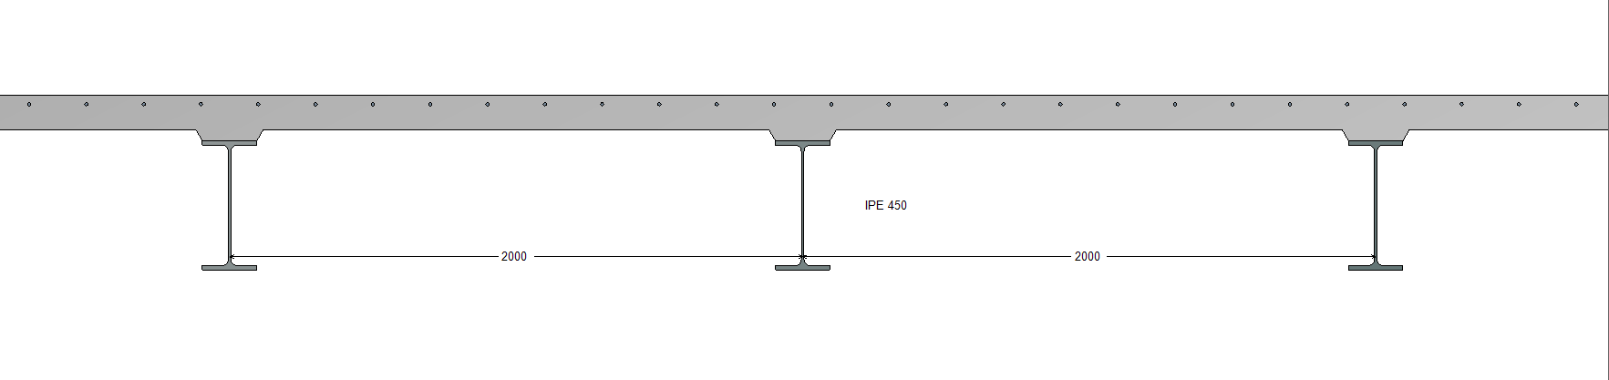
Figure 1 : Transversal view

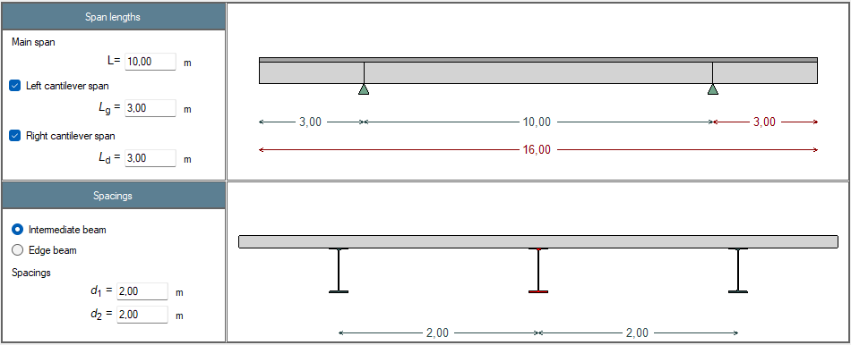
Figure 2 : Definition of the beam
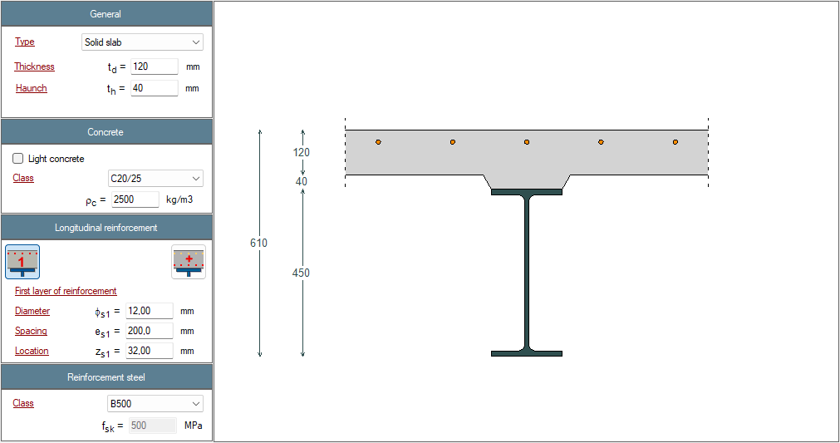
Figure 3 : Definition of the slab

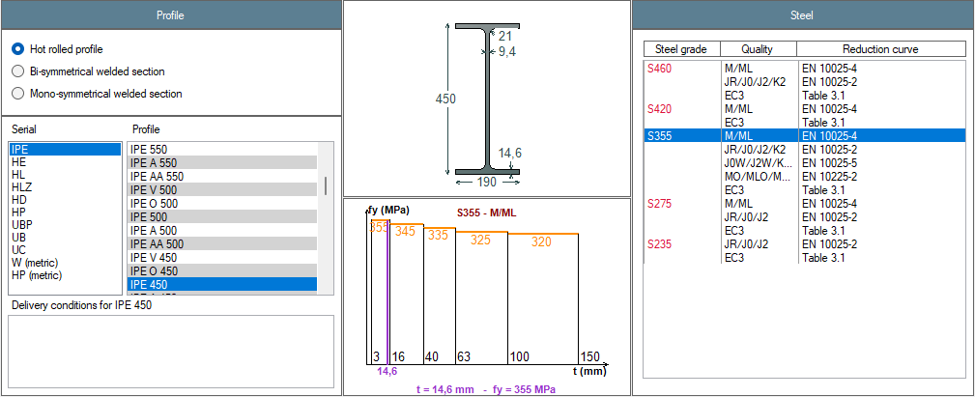
Figure 5 : Definition of the steel profile

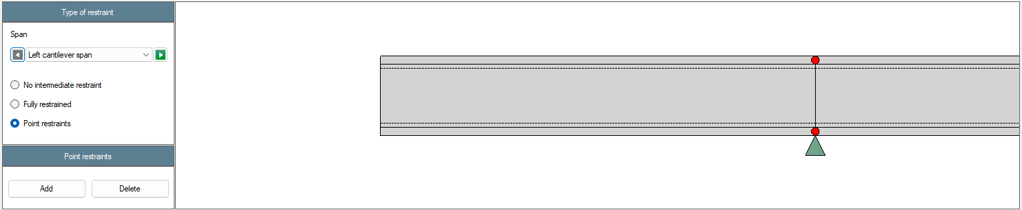
Figure 7 : Definition of the lateral restraints (left cantilever)
Figure 7 : Definition of the lateral restraints (left cantilever)

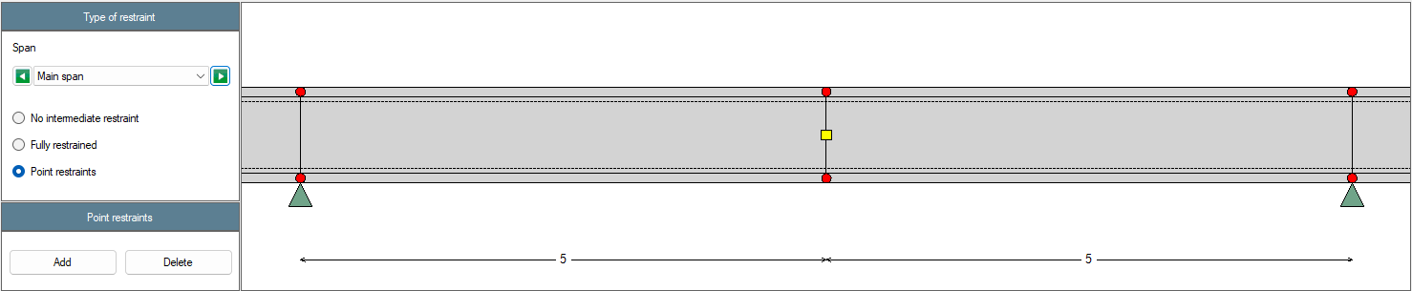
Figure 7 : Definition of the lateral restraints (main span)

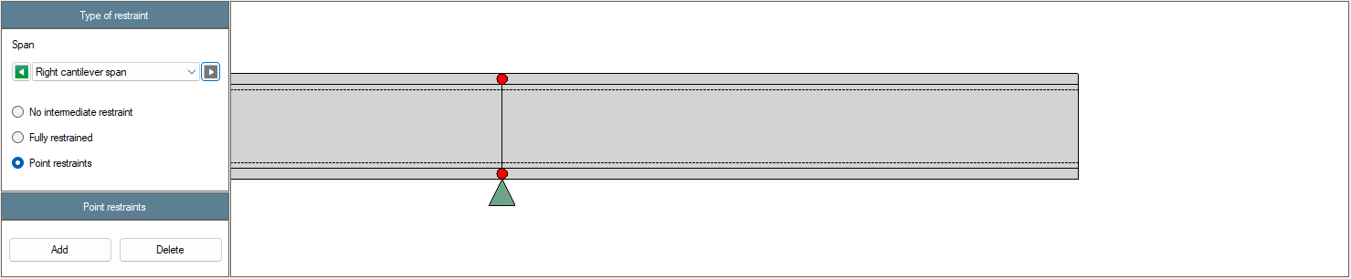
Figure 7 : Definition of the lateral restraints (right cantilever)

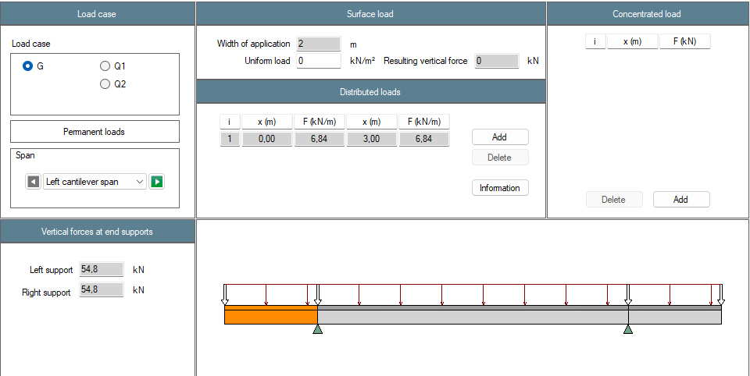
Figure 10 : Definition of the load cases – Permanent loads G1 (left cantilever)
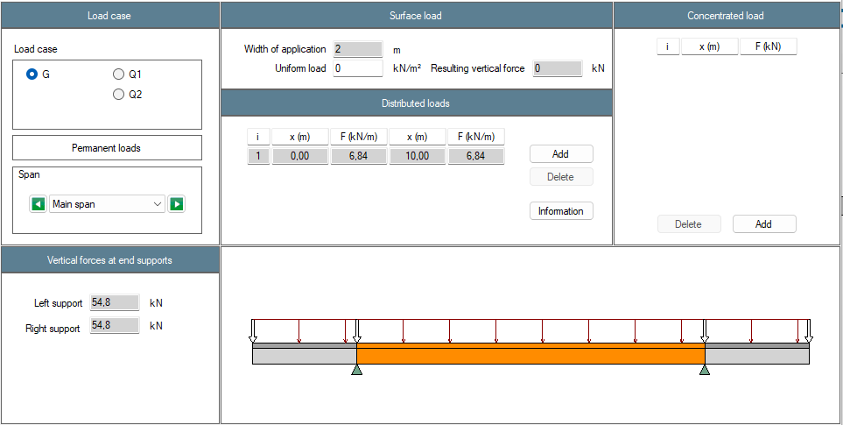
Figure 10 : Definition of the load cases – Permanent loads G1 (main span)

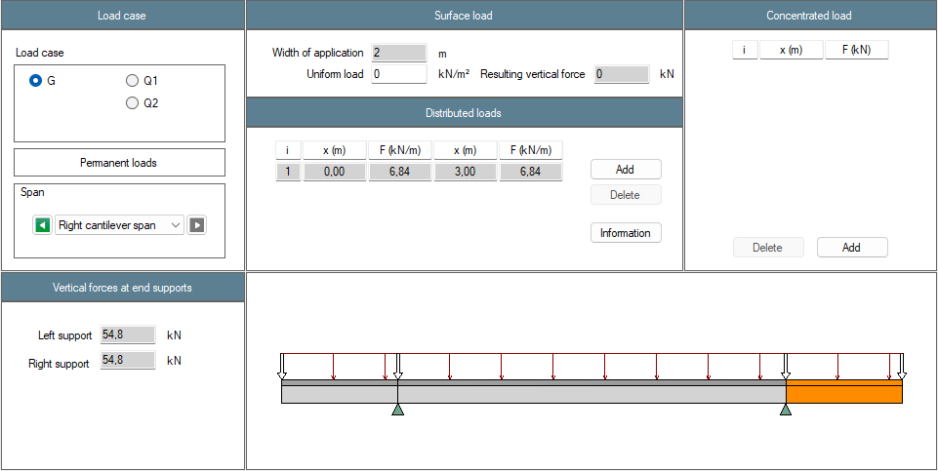
Figure 10 : Definition of the load cases – Permanent loads G1 (right cantilever)

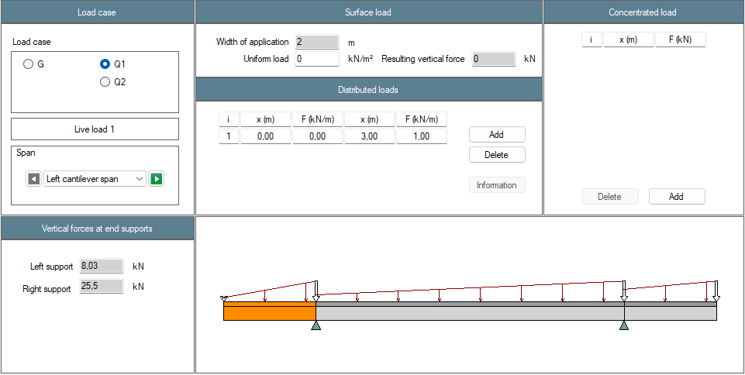
Figure 10 : Definition of the load cases – Live load Q1 (left cantilever)

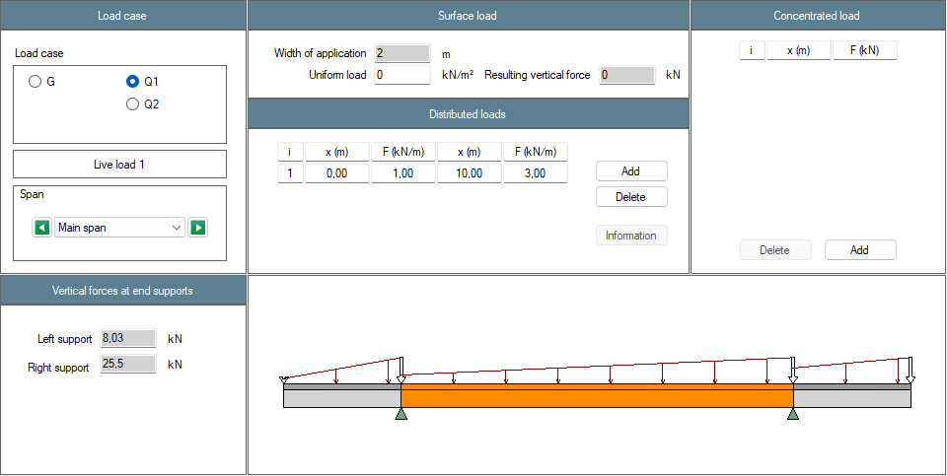
Figure 10 : Definition of the load cases – Live load Q1 (main span)

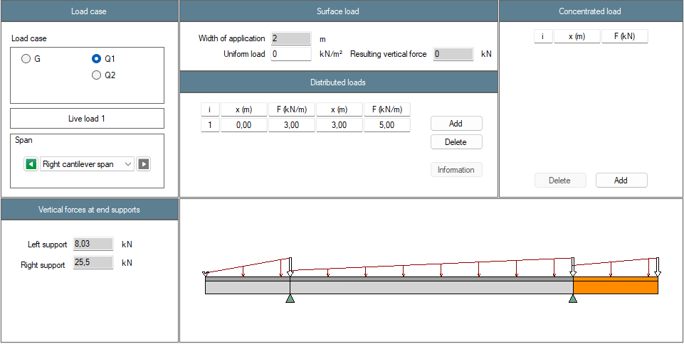
Figure 10 : Definition of the load cases – Live loads Q1 (right cantilever)

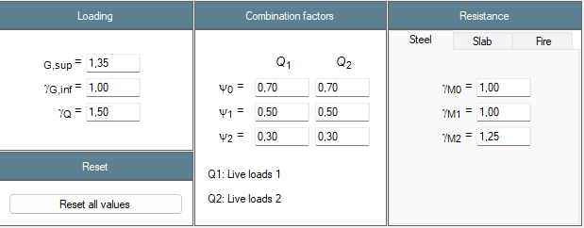
Figure 7 : Definition of the national parameters

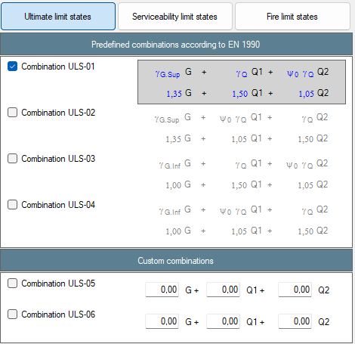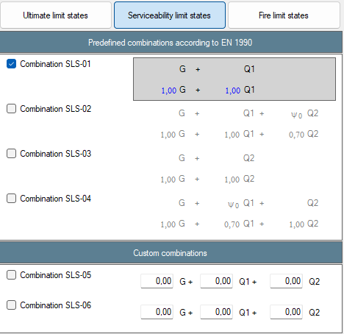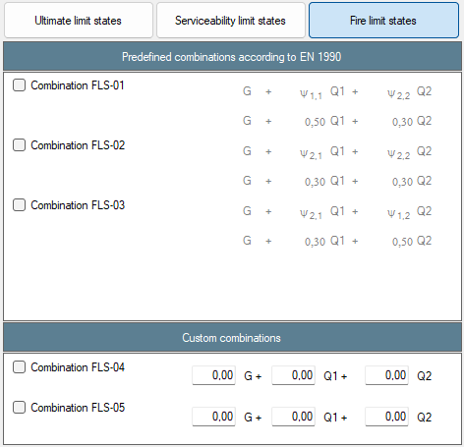
Figure 7 : Definition of the combinations
Figure 18 : Beam calculation options
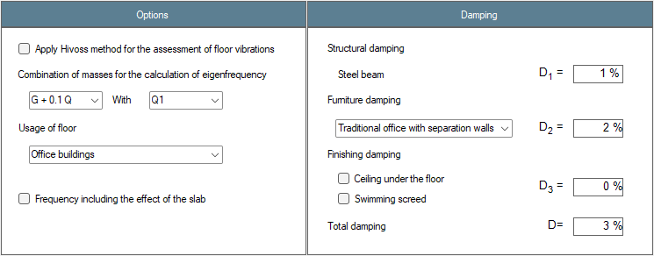
Figure 19 : Floor vibrations parameters

Results
Résultats | Reference | ABCPMX | Dev.
Cross-sectional area : $A$ = (cm²) | 98.8 | 98.8 | 0.00%
Shear area : $A_{v}$ = (cm²) | 50.8 | 50.8 | 0.00%
Moment of inertia about y-y axis : $I_{y}$ = (cm⁴) | 33 740 | 33 743 | 0.01%
Moment of inertia about z-z axis : $I_{z}$ = (cm⁴) | 1 676 | 1 672 | 0.24%
Elastic section modulus about y-y axis : $W_{el,y}$ = (cm³) | 1 500 | 1 500 | 0.00%
Elastic section modulus about z-z axis : $W_{el,z}$ = (cm³) | 176 | 176 | 0.00%
Plastic section modulus about y-y axis : $W_{pl,y}$ = (cm³) | 1 702 | 1 702 | 0.00%
Plastic section modulus about z-z axis : $W_{pl,z}$ = (cm³) | 276 | 272.8 | 1.17%
Torsional moment : $I_{t}$ = (cm⁴) | 66.66 | 66.75 | 0.13%
Warping moment : $I_{w}$ = (cm⁶) | 780 739 | 791 005 | 1.30%
Linear mass : $m_{lin}$ = (kg/ml) | 77.7 | 77.6 | 0.13%
Mass : $m$ = (kg) | 1 243 | 1 241 | 0.16%
Total paint surface : $S$ = (cm²) | 256 824 | 256 824 | 0.00%
Paint surface (without upper face) : $S$ = (cm²) | 226 424 | 226 424 | 0.00%
Massiveness : $M$ = (m⁻¹) | 162.4 | 162.4 | 0.00%
Massiveness (without upper face) : $M$ = (m⁻¹) | 143.2 | 143.2 | 0.00%
Nominal yield strenght : $f_{y}$ = (MPa) | 355 | 355 | 0.00%
Young’s modulus : $E$ = (MPa) | 210 000 | 210 000 | 0.00%
Density : $ρ$ = (kg/m³) | 7 850 | 7 850 | 0.00%
Tensile resistance : $N_{t,Rd}$ = (kN) | 3 508 | 3 508 | 0.00%
Shear resistance : $V_{pl,Rd}$ = (kN) | 1 402 | 1 402 | 0.00%
Plastic moment resistant : $M_{pl,Rd}$ = (kN.m) | 604 | 604 | 0.00%
Elastic moment resistant : $M_{el,Rd}$ = (kN.m) | 532 | 532 | 0.00%
Section class for bending : | 1 | 1 | 0.00%
Section class for compression : | 4 | 4 | 0.00%
Shear buckling resistance : $h_{w}/t_{w}$ = | 40.3 | 40.3 | 0.00%
Shear buckling resistance : $72ε/η$ = | 48.8 | 48.8 | 0.00%
Verification of web buckling necessary ? | No | No | OK
Table 1: Steel profile

Résultats | Reference | ABCPMX | Dev.
Shear force : $V(G_{1})=$ (kN) | 34.4 | 34.2 | 0.58%
Bending moment : $M(G_{1})=$ (kN.m) | 55.1/-31 | 54.7/-30.8 | 0.73%/0.65%
Shear force : $V(Q_{1}\#1)=$ (kN) | 13.5 | 13.5 | 0.00%
Bending moment : $M(Q_{1}\#1)=$ (kN.m) | 14.7/-19.5 | 14.7/-19.5 | 0.00%/0.00%
Shear force : $V(Q_{1}\#2)=$ (kN) | 11.7 | 11.7 | 0.00%
Bending moment : $M(Q_{1}\#2)=$ (kN.m) | 25.2 | 25.2 | 0.00%
Shear force : $V(Q_{1}\#3)=$ (kN) | 12 | 12 | 0.00%
Bending moment : $M(Q_{1}\#3)=$ (kN.m) | -19.5 | -19.5 | 0.00%
Shear force : $V_{Ed,ULS\#1}=$ (kN) | 66.7 | 66.4 | 0.45%
Bending moment : $M_{Ed,ULS\#1}=$ (kN.m) | 96.2/-71.1 | 95.7/-70.8 | 0.52%/0.42%
Shear force : $V_{Ed,ULS\#2}=$ (kN) | 64.0 | 63.7 | 0.47%
Bending moment : $M_{Ed,ULS\#2}=$ (kN.m) | 112/-41.8 | 111/-41.6 | 0.90%/0.48%
Shear force : $V_{Ed,ULS\#3}=$ (kN) | 49.2 | 48.9 | 0.61%
Bending moment : $M_{Ed,SLS\#3}=$ (kN.m) | 59.0/-71.1 | 58.5/-70.8 | 0.85%/0.42%
Table 4: Analysis

Résultats | Reference | ABCPMX | Dev.
Resistance to bending moment : $Γ_{M,ULS\#1}=$ | 0.16 | 0.16 | 0.00%
Resistance to shear force : $Γ_{V,ULS\#1}=$ | 0.06 | 0.06 | 0.00%
Resistance to MV interaction : $Γ_{MV,ULS\#1}=$ | 0.16 | 0.16 | 0.00%
Critical moment to lateral torsional buckling : $M_{cr,ULS\#1}$ (kN.m) |  | 239.6
Resistance to lateral torsional buckling : $Γ_{LT,ULS\#1}=$ |  | 0.29
Resistance to bending moment : $Γ_{M,ULS\#2}=$ | 0.19 | 0.18 | 5.56%
Resistance to shear force : $Γ_{V,ULS\#2}=$ | 0.06 | 0.06 | 0.00%
Resistance to MV interaction : $Γ_{MV,ULS\#2}=$ | 0.19 | 0.18 | 5.56%
Critical moment to lateral torsional buckling : $M_{cr,ULS\#2}$ (kN.m) |  | 203.4
Resistance to lateral torsional buckling : $Γ_{LT,ULS\#2}=$ |  | 0.33
Resistance to bending moment : $Γ_{M,ULS\#3}=$ | 0.12 | 0.12 | 0.00%
Resistance to shear force : $Γ_{V,ULS\#3}=$ | 0.05 | 0.05 | 0.00%
Resistance to MV interaction : $Γ_{MV,ULS\#3}=$ | 0.12 | 0.12 | 0.00%
Critical moment to lateral torsional buckling : $M_{cr,ULS\#3}$ (kN.m) |  | 307.6
Resistance to lateral torsional buckling : $Γ_{LT,ULS\#3}=$ |  | 0.22
Table 5: ULS

Résultats | Reference | ABCPMX | Dev.
Deflection : $δ(G_{1})$ (mm) |  | 7.14
Deflection : $δ(Q_{1}\#1)$ (mm) |  | 1.83
Deflection : $δ(Q_{1}\#2)$ (mm) |  | 3.68
Deflection : $δ(Q_{1}\#3)$ (mm) |  | 3.50
Deflection : $δ(SLS\#1)$ (mm) |  | 8.96
Deflection : $δ(SLS\#2)$ (mm) |  | 10.8
Deflection : $δ(SLS\#3)$ (mm) |  | 5.30
Table 7: SLS assuming full connection

